Southwark’s Sustainable Transport Strategy - Group Consultation Response Template
Consultation 6 December 2022 – 5 February 2023
About your consultation response
Name of group or organisation
Contact person and their title/job role
Purpose of your organisation
(a brief description of what you do)
Number of members
Number of members consulted in preparing this response
Briefly describe how this response was compiled. Did you host a group session, contacted people in other ways to let them know how to input etc.

Background
Southwark’s Sustainable Transport Strategy sets out our approach to improve people’s experience of travel to, from and around the borough. People’s wellbeing and their experiences of moving are at the heart of the strategy. This builds on the lessons learnt from the delivery of the Movement Plan 2019 and continuous engagement which took place over the past few years.
When we published the Movement Plan in 2019, we set out to update our strategy every five years. However, since then the world has changed greatly. Faced with the realities of climate, health and air pollution crises, we need to act quickly and ambitiously, against a background of declining funding. For these reasons we are updating our strategy now and we would welcome your views on how you are experiencing these changes and how we can work together to deliver our nine missions.
Why your views matter
We are committed to work together to provide the best possible experience for people who travel around the borough.
We asked the views of Southwark residents in 2019 when consulting on the Movement Plan, and have collected information from several other consultations that the council has carried out in recent years. We have defined our missions and objectives based on this information, our professional expertise, data, research, and working together with council colleagues.
We want to know from the perspective of your group or organisation how we can efficiently and innovatively deliver the Sustainable Transport Strategy and what opportunities you see.
How to fill out the template
We have provided a set of questions to guide your group discussion. Please use these as the basis for your group consultation activity and note the key points of your discussion in the template below.
Submit your response, as PDF or Word Document by emailing highways@southwark.gov.uk before 5 February 2023. Please title the email 'Sustainable Transport Strategy Consultation’
Do you want to share your view as an individual?
Please fill out the online consultation survey at http://www.southwark.gov.uk/STS

Discussion points
(1) The vision
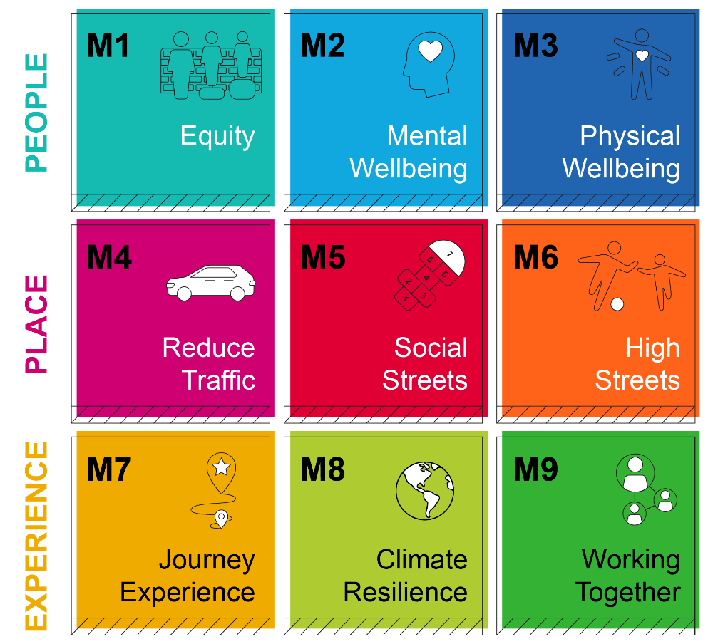

Our vision is for Southwark to be a sustainable borough, with zero emissions from transport, and where no one is prevented from accessing healthy travel options.

By 2030, streets will be quieter, cleaner, and safer, with reduced speeds and volume of private motor vehicles. Our town centres, high streets and places where you change from one type of transport to another will be more spacious, prosperous and enjoyable places to spend more time in.

Walking, cycling, scooting, and wheeling will be how more people choose to travel locally. The borough will be better prepared for the impacts of climate change.

Q1.1 To what extent do you disagree/agree with this vision?

Strongly Disagree Disagree Neutral Agree Strongly Agree

Q1.2 Please explain your reasons?

Write your answer here

(2) Priorities and objectives

Q2.1 Looking at the list of 22 objectives at the end of this document, which three objectives would you highlight as your priorities and why?

Write your answer here

Q2.2 What change would you hope these achieve?

Write your answer here

Q2.3 What practical suggestions would you have for delivering these objectives?

Write your answer here

(3) Other
Q3. From reading the ‘Sustainable Transport Strategy Consultation Draft’, is there anything else we could include in the Sustainable Transport Strategy?
Write your answer here

Summary of STS 2022 Missions and Objectives
Mission | Objective
People
M1 Fairer streets for all  Equity means taking everyone’s needs into account and providing a solution that is accessible, affordable, safe and fair to all. This principle will guide our approach to supporting transport in Southwark. | 1. Prioritise equity in all transport schemes so everyone can achieve their potential.
M2 Deliver streets and spaces that support mental wellbeing  We experience streets and spaces through our senses; and noisy, busy and cluttered spaces affect our mental wellbeing. We want to create enjoyable spaces that help people feel calm and relaxed | 2. Create calm and simple streets
M3 Deliver streets and spaces that support physical wellbeing  Despite the clear benefits of active travel and being more physically active, many barriers prevent people from doing it. Our focus will be to address these challenges to make it easier for people to get active and stay active. | 3. Encourage people to get active and stay active  4. Design our streets to enable everyone to use the space actively, efficiently and safely  5. Provide infrastructure and facilities that support active travel
Place
M4 Reduce Traffic  Reducing traffic will reduce congestion, improve road safety and air quality, and create calmer, healthier streets with more space for people | 6. Expand vehicle-free space and the wider pedestrian realm  7. Reduce ownership of private cars  8. Expand the shared mobility network  9. Ensure the safe and efficient operation of the road network
M5 Transform our streets into social thriving neighbourhoods  People should feel comfortable, secure and welcomed in their neighbourhood. It is where we live and spend most of our time. We want to create spaces that encourage people to participate in their community. | 10. Creating thriving neighbourhoods with things to see and do, and places that encourage a sense of belonging.  11. Make town centres attractive, thriving and diverse places for people and businesses
M6 Support sustainable and efficient freight and servicing  The local economy is affected by how people and goods move around, and how people use public space. Proper management of freight and servicing can help support people and the local economy sustainably. | 12. Support the development of a sustainable freight and servicing supply chain
Experience
M7 Safe clean and comfortable journey experience for all  We tend to judge journeys in terms of the time taken to get from beginning to end. However, improving the quality of the journey itself is a big opportunity to encourage more people to travel sustainably by making it the more convenient and enjoyable choice. | 13. Deliver Vision Zero: Zero people killed or seriously injured on our streets  14. Improve personal safety on streets and public places  15. Maintain our streets in good condition  16. Working with TfL and other transport operators to make public transport safe, accessible, and reliable for a growing population
M8 Places to be adaptable and resilient to climate change  The council declared a climate emergency in 2019. Extreme weather will become more common as a result of climate change; we want places to mitigate these effects. | 17. Mitigate flood risk  18. Use available space to introduce new greenery and opportunities for biodiversity
M9 Working together to deliver the Sustainable Transport strategy  To feel seen and be heard, to be able to share your experience and views is important. Working collaboratively and towards the same goals with consistent messaging is also very important. Data and new technology will help us do that. | 19. Be consistent in our messaging and ensure access to relevant information  20. Engage, support and co-create with communities  21. Work with schools and young people to deliver the Sustainable Transport Strategy  22. Collect and analyse data and stay up to date with new technologies to improve our practices

