

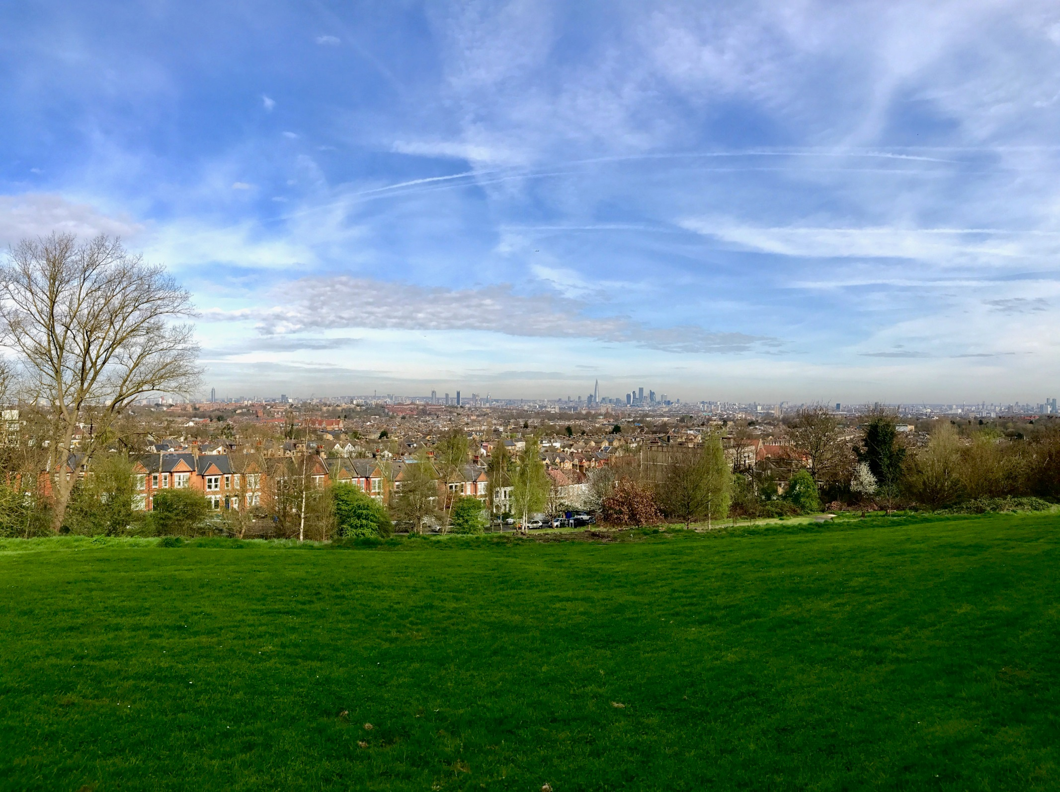

**SOUTHWARK AIR QUALITY ACTION PLAN**

2023 – 2027

Consultation Draft Copy

If you have any comments on this AQAP please send them to Southwark Environmental Protection at:

Environmental Protection Team,

Regulatory Services,

Environment, Leisure and Public Health,

3rd Floor Hub 1, 160 Tooley Street

London. SE1 2QH

Telephone: - 020 7525 3551

Email: - [environmental.protection@southwark.gov.uk](mailto:environmental.protection@southwark.gov.uk)

### SUMMARY

This Air Quality Action Plan (AQAP) has been produced as part of our duty under London Local Air Quality Management. It outlines the action we will take to improve air quality in Southwark between 2023 and 2027.

This action plan replaces the previous action plan which ran from 2017 to 2022. Successful projects delivered through the last action plan include:

* Expansion of Southwark’s Air Quality Monitoring Network.
* Reduced the council’s pension investment in fossil fuels.
* Production of Air Quality Planning Technical guidance document.
* Improved cycling and walking provisions in the Borough.
* Introduction of Low Transport Neighbourhoods in the Borough.
* Introduction of electric pool vehicles.
* Production of an Air Quality Joint Strategy Needs Assessment.
* The Southwark fleet procurement policy worked on the following hierarchy: - is the vehicle necessary, if so, the vehicle should be electrically powered. If an electric option is not available, the vehicle should be petrol fuelled. Diesel is only permitted when it is the only viable option.
* 2 Primary Schools and 3 nurseries in the Borough received a Mayor’s Air Quality audit.
* Produced Air Quality / Health Information Sheets
* Completed or taking part in the following Mayor’s Air Quality Fund projects, details can be found on [Southwark’s website](https://www.southwark.gov.uk/environment/air-quality/what-we-re-doing/air-quality-projects).
  + Cleaner Air for Schools Projects Phase 1 and 2
  + Anti – idling project at Tower Bridge
  + Air quality issues awareness raising
  + Construction site dust suppressant trial
  + Trial of Nitrogen Dioxide reducing reactive surface coatings on new developments.
  + Regulation of construction site Non-Road Mobile Machinery in conjunction with London Borough of Merton
  + Anti – idling project: ‘Idling Action London’ in conjunction London Borough of Camden / City of London
* Emission based vehicle parking charges for on street parking and permits.
* Worked with TfL to reduce emissions from Rotherhithe Tunnel.
* GLA Air Quality Focus Area air quality projects.

Air pollution causes adverse health impacts, and contributes to the onset of heart disease and cancer. Air pollution particularly affects the most vulnerable in society: children and older people, and those with heart and lung conditions. Air quality is an equalities issue, because areas with poor air quality are often also the less affluent areas.[1] [2]

[Southwark’s Air Quality Joint Strategy Needs Assessment](https://www.southwark.gov.uk/assets/attach/6353/Final-Air-Quality-JSNA-March-2018.pdf) (JSNA) on page 28 and 29 shows the GLA Air Quality Focus Areas in relationship to the number of children (0 – 15 years), number of older people aged 65+ and the percentage of deprived communities and ethnic minority. Higher percentages of deprived communities and ethnic minority are in, or adjacent to, air quality focus areas.

The annual health costs to society of the impacts of air pollution in the UK is estimated to be roughly £15 billion[3]. L.B. Southwark is committed to reducing the exposure of people in Southwark to poor air quality in order to improve health.

We have developed actions under seven broad topics:

* **Monitoring and other core statutory duties:** Southwark has expanded its continuous monitoring network to six sites. This improves information about changes in air quality over time. The new equipment also allows Council to monitor more pollutants that are in the air. Council has made the information publicly available to help inform about air pollution.
* **Emissions from developments and buildings:** emissions from buildings account for about 21% of the NOX emissions across London, so are an important source of NO2. Southwark seeks to reduce emissions from fuel combustion. This aim aligns with the Southwark Carbon strategy.
* **Public health and awareness raising**: Increasing awareness can drive behavioural change that lowers emissions, and informs the public how to reduce their exposure to air pollution;
* **Delivery servicing and freight**: Goods and service vehicles are usually diesel powered and have high NO2 emissions. Low emission logistics requires alternatively fuelled vehicles to combat air pollution from this source;
* **Borough fleet actions**: Southwark’s fleet includes light and heavy duty diesel-fuelled vehicles such as mini buses and refuse collection vehicles with high primary NO2 emissions. Southwark can review its own fleet procurement to lead by example;
* **Localised solutions**: Supporting neighbourhoods to introduce information or undertake actions to improve air quality;
* **Cleaner transport:** Road transport is the main source of air pollution in London. There is a need to incentivise a modal shift to walking, cycling and ultra-low emission vehicles (such as electric).

**Southwark’s themes & priorities**

***1 Monitoring and other core statutory duties:***evaluating air quality monitoring throughout Southwark to enhance compliance with our core statutory objectives;

***2 Emissions from development and buildings:***emissions from construction alone accounts for approximately 40% of the PM10 emissions across Southwark, and therefore work in this area is important in reducing particulate concentrations. This will focus on air quality mitigation through the planning system and correlates with the Council’s sustainability objectives;

***3 Public health and awareness raising:*** increasing awareness can drive behavioural change to lower emissions as well as reducing exposure to air pollution. For example, a shift in attitude with respect to solid fuel burning through increasing awareness of the impact this causes, can help facilitate overall behaviour change;

***4 Delivery servicing and freight:*** ensuring delivery servicing and freight vehicles are re-evaluated as these are usually heavy-duty diesel-fuelled vehicles with high primary NO2 emissions;

***5 Borough fleet:***Southwark’s fleet includes a mixture of light and specialist heavy-duty vehicles, we will continue to make improvements in our own fleet, thereby leading by example;

***6 Localised solutions:*** these seek to improve the environment of neighbourhoods through a combination of measures such as Low Traffic Neighbourhoods, traffic filtering, parking schemes biodiversity and climate change projects;

***7 Cleaner transport:***road transport is the main source of air pollution in London and Southwark. We have been and will continue to incentivise and facilitate a change to walking, cycling, public transport and ultra-low emission vehicles (such as electric) as far as possible;

***8 Schools and communities:***implementing initiatives that target the most susceptible groups in Southwark in order to ensure those most at risk are not disproportionately affected by the impacts of poor air quality and implement the recommendations from Southwark’s School Air Quality Audits;

***9 Lobbying:*** Southwark will continue to lobby and influence regional and national organisations and stakeholders on policies and issues beyond Southwark’s influence to introduce progressive measures aimed at improving air quality.

**Our 10 key priorities are:-**

1. Adopt the 2005 WHO guidelines for PM2.5 with a target of compliance deadline by 2030, and review the emerging policies from the GLA in respect of the 2021 WHO guidelines
2. Ensure enforcement of Non-Road Mobile Machinery (NRMM) air quality policies in Southwark.
3. Minimise emissions from construction through the development of Southwark’s own Air Quality Supplementary Planning Document (SPD) and code of construction for which goes above and beyond the GLA Supplementary Planning Guidance (SPG);
4. Continue to raise awareness and encourage behaviour changes through air quality campaigns
5. Assess potential impact of installing Ultra-Low Emission Vehicle (ULEV) infrastructure (electric vehicle charging points, rapid electric vehicle charging points).
6. Increase uptake of electric vehicles and ensure electric vehicle charging infrastructure provision and maintenance keeps pace with growth in Southwark.
7. Assess the air quality benefits of the actions in the Borough’s Strategies
8. Provide new cycling and walking infrastructure and assess air quality impacts of new infrastructure.
9. Deliver updated Parking and Enforcement Plan on the Southwark’s Estates to align with the On-street Parking Policies.
10. Lobby Central Government to control and reduce emissions that are out of Southwark’s control.

This action plan sets out how we will effectively deliver against the above broad themes and key priorities, thereby improving air quality issues that are within our control and through leading by example. However, it is important to recognise that these are local drivers reduced at tackling air pollution and that air pollution by its very nature is transboundary.

Engagement with stakeholders and communities can make a difference to air quality in the borough. We would like to thank everyone who worked with us in the past, and we look forward to working with you again, and with new partners as we deliver this new action plan over the next five years.

This AQAP outlines how we plan to use local levers under our control to greatest effect in tackling air quality.

However, there are many air quality policy areas outside our influence (such as Euro standards, national vehicle taxation policy, taxis and buses), and we will continue to work with and lobby regional and central government on policies and issues beyond Southwark’s direct control.

**RESPONSIBILITIES AND COMMITMENT**

This AQAP was prepared by the Environmental Protection Team of Southwark Council with the support and agreement of the following officers and departments:

Officers from the following teams and departments have been involved in the preparation of this Air Quality Action Plan:-

* Environmental Protection
* Public Health
* Transport Policy
* Planning Policy
* Sustainable Services
* Highways
* Climate Change
* External Affairs
* Legal Services
* Public Realm
* Parks
* Ecology &Trees
* Development Control
* Children’s Services & Educational Development
* Housing Services & Housing Energy
* Fleet Management
* IT
* Comms
* Procurement

This AQAP has been approved by:

This Air Quality Action Plan has been ratified by Southwark’s Cabinet, endorsed by the Cabinet Member for Transport, Parks and Sport, and approved by the Head of Public Health, and Head of Transport and Planning.

This AQAP will be subject to an annual review, appraisal of progress and reporting to the Cabinet Member for Leisure, Environment & Roads, and to the Health & Wellbeing Board.Progress each year will be reported in an Annual Status Report produced by Southwark, as part of our statutory London Local Air Quality Management duties.

### CONTENTS

SUMMARY 3

CONTENTS 8

FORWARD 11

1 - INTRODUCTION 12

2 - SOUTHWARK’S AIR QUALITY PRIORITIES 36

3 - DEVELOPMENT AND IMPLEMENTATION OF SOUTHWARK’S AIR QUALITY ACTION PLAN 38

4 – AIR QUALITY ACTION PLAN 40

APPENDIX A – RESPONSE TO CONSULTATION 62

APPENDIX B - REASONS FOR NOT PURSUING ACTION PLAN MEASURES 65

#### **Table of Figures**

Figure 1 Modelled map of annual mean NO2 concentrations (from the LAEI 2016) 13

Figure 2 Modelled map of annual mean PM10 (from the LAEI 2016) 14

Figure 3 Modelled map of annual mean PM2.5 (from the LAEI 2016) 15

Figure 4 Modelled map of annual mean NO2 concentrations (from the LAEI 2019) 16

Figure 5 Modelled map of annual mean PM10 concentrations (from the LAEI 2019) 17

Figure 6 Modelled map of annual mean PM2.5, based on census output areasaverageconcentrations (from the LAEI 2019) 18

Figure 5 Map of Southwark’s AQMA Boundary 20

Figure 6 Air Quality Focus Areas in Southwark 21

Figure 7 Tower Bridge Primary School green wall on Tower Bridge Road boundary 23

Figure 8 Walworth Low Emission Neighbourhood publicity material 24

Figure 9 NOx Emissions by source and vehicle type (from the LAEI 2016) 25

Figure 10PM10 Emissions by source and vehicle type (from the LAEI 2016) 27

Figure 11 PM2.5 Emissions by source and vehicle type (from the LAEI 2016) 29

Figure 12 Map of the Southwark’s automatic continuous air quality monitoring stations 33

Figure 13 Southwark’s Nitrogen Dioxide diffusion tube survey 2021 34

Figure 14 Trend in annual mean NO2 concentrations at Southwark’s air quality monitoring stations 35

Figure 15 Trend in annual mean PM10 concentrations at Southwark’s air quality monitoring stations 35

#### **Index of Tables**

Table A GLA Air Quality Focus Areas in Southwark 21

Table B NOx Aggregated Emissions in Southwark for 2013-2019 (LAEI 2019) 26

Table C PM10 Aggregated Emissions in Southwark for 2013 – 2019 (LAEI 2019) 28

Table D PM 2.5 Aggregated Emissions in Southwark for 2013 – 2019 (LAEI 2019) 30

Table E Southwark automatic continuous monitoring stations 31

Table F Consultation Undertaken 38

Action Table 1 Monitoring and Core Statutory Duties Air Quality Action Plan 42

Action Table 2 Emissions from developments and buildings air quality action plan 45

Action Table 3 Public health and awareness raising air quality action 51

Action Table 4 Delivery servicing and freight air quality action plan 55

Action Table 5 Borough fleet actions air quality action plan 56

Action Table 6 Localised solutions air quality action plan 57

Action Table 7 Cleaner transport air quality action plan 59

Table G Summary of Responses to Consultation and Stakeholder Engagement on the AQAP 62

Table H Action Plan Measures Not Pursued and the Reasons for that Decision – to be discussed with the GLA prior to finalisation 65

### FORWARD

*This should include a statement and signature from the relevant Cabinet Member/s. It is strongly recommended that there is also signature of the Director of Public Health and the Head of Transport, along with a joint statement of intent to work together to deliver the shared aims of improving air pollution.*

*If there are any other local organisations or networks that are playing a significant role in air quality it may also be beneficial to include brief comment on that here.*

***To be written after the consultation period***

### 1 - INTRODUCTION

This plan outlines the actions that Southwark will deliver between 2022 and 2027 to reduce concentrations of air pollution, and exposure to air pollution; to affect positively the health and quality of life of residents and visitors to the borough.

It has been developed in recognition of the legal requirement on the local authority to work towards air quality objectives under Part IV of the Environment Act 1995 and relevant regulations made under that part and to meet the requirements of the London Local Air Quality Management statutory process[4].

#### **1.1 Summary of current air quality in Southwark**

The 2019 UK Clean Air Strategy, provides the overarching strategic framework for air quality management in the UK and contains national air quality standards and objectives established by the Government to protect human health. The Strategy objectives take into account limit values set under EU Directives. Member states are legally required to achieve by their target dates, and on leaving the EU, the UK has incorporated this requirement into national law.

Reviewing Southwark’s monitoring data over the last few years show that Southwark is meeting all of the national objectives other than for Nitrogen Dioxide (NO2).The monitoring data in 2020 has been influenced by the reduced in traffic flows in response to the COVID-19 lockdowns. The 2016 London Atmospheric Emission Inventory concentration maps show that there are areas in Southwark that exceed the legal objectives.

For PM2.5 the legal objective is far higher than the World Health Organisation (WHO) recommended guideline limit. For this reason, the Mayor’s London Environment Strategy commits to meeting the 2005 WHO health-based guideline limits across London by 2030. Current air quality data indicates that Southwark is exceeding World Health Organisation guideline PM2.5 limits. Developing measures to reduce PM2.5 will be important to help the Mayor achieve this 2030 target*.*

Particular Matter (PM) is the term for a mixture of solid particles and liquid droplets found in the air. Some particles, such as dust, dirt, soot, or smoke, are large or dark enough to be seen with the naked eye. Others are so small they can only be detected using an electron microscope.

Particle pollution includes:

* **PM10** : are inhalable particles, with diameters that are generally 10 micrometres and smaller; and
* **PM2.5** are fine inhalable particles, with diameters that are generally 2.5 micrometres and smaller. In comparison a diameter of a single hair from your head is about 70 micrometres in diameter – making it about 30 times larger than the largest fine particle.

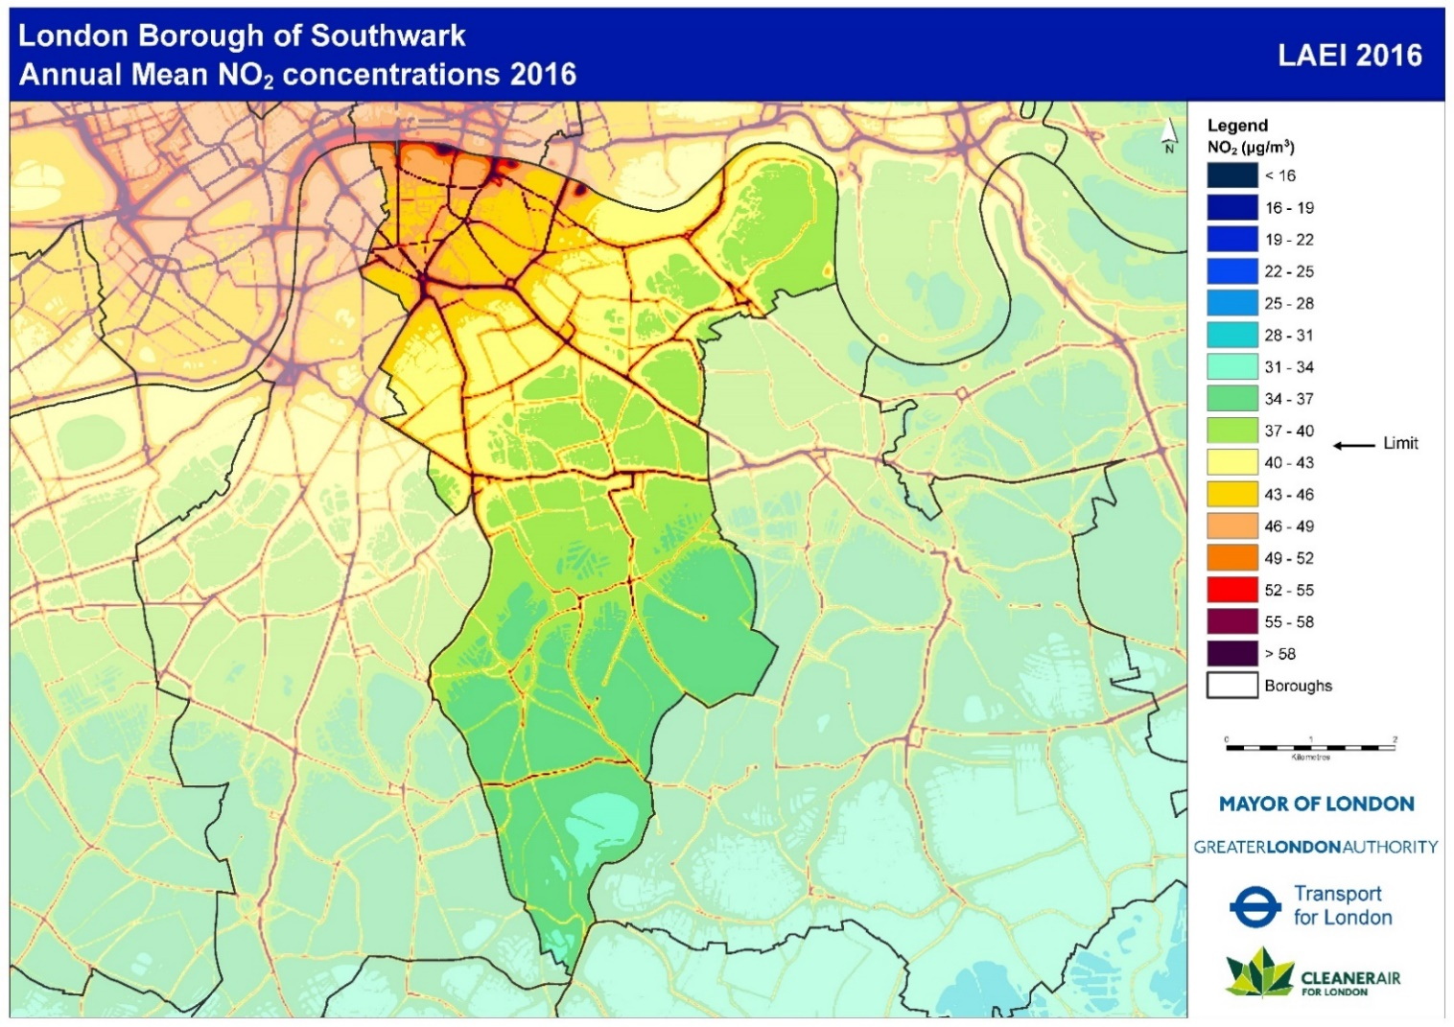

Figure 1 Modelled map of annual mean NO2 concentrations (from the LAEI 2016)

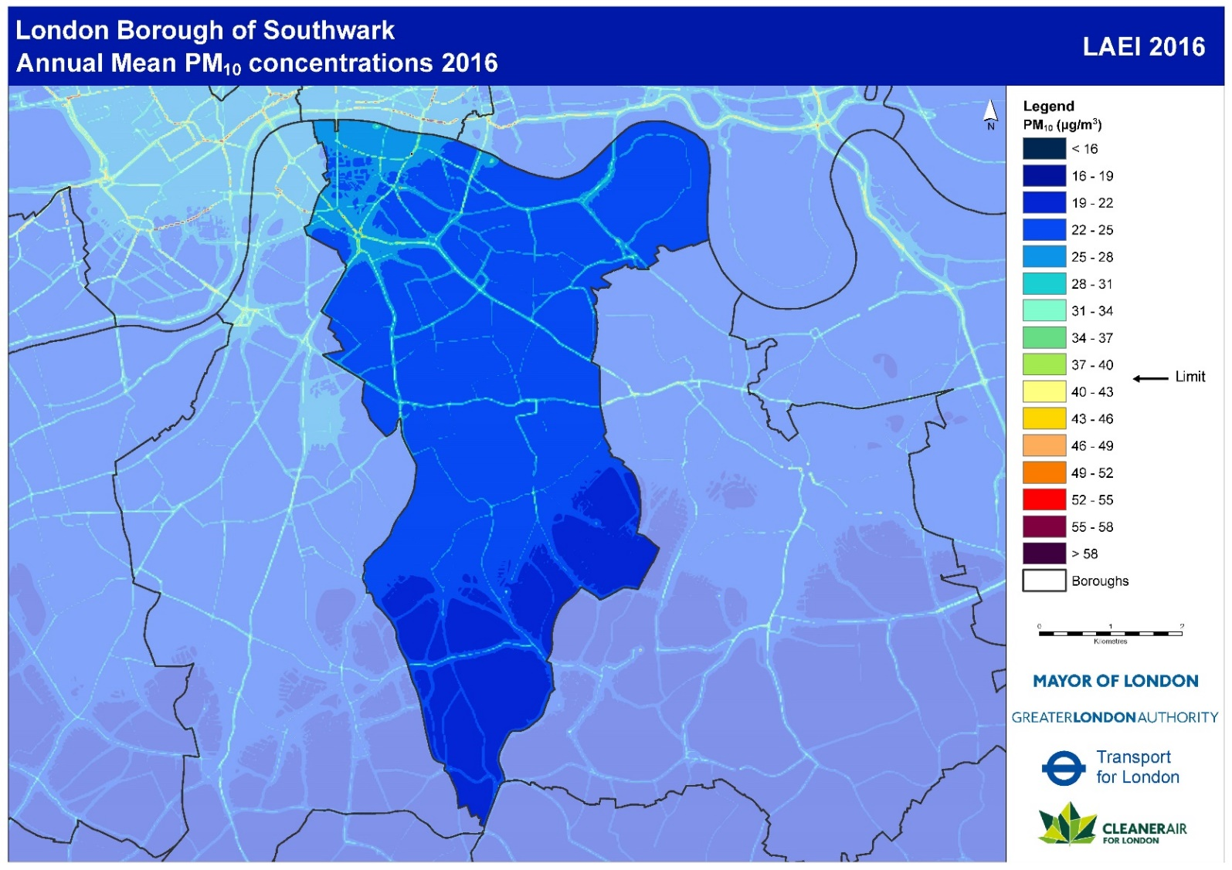

Figure 2 Modelled map of annual mean PM10 (from the LAEI 2016)

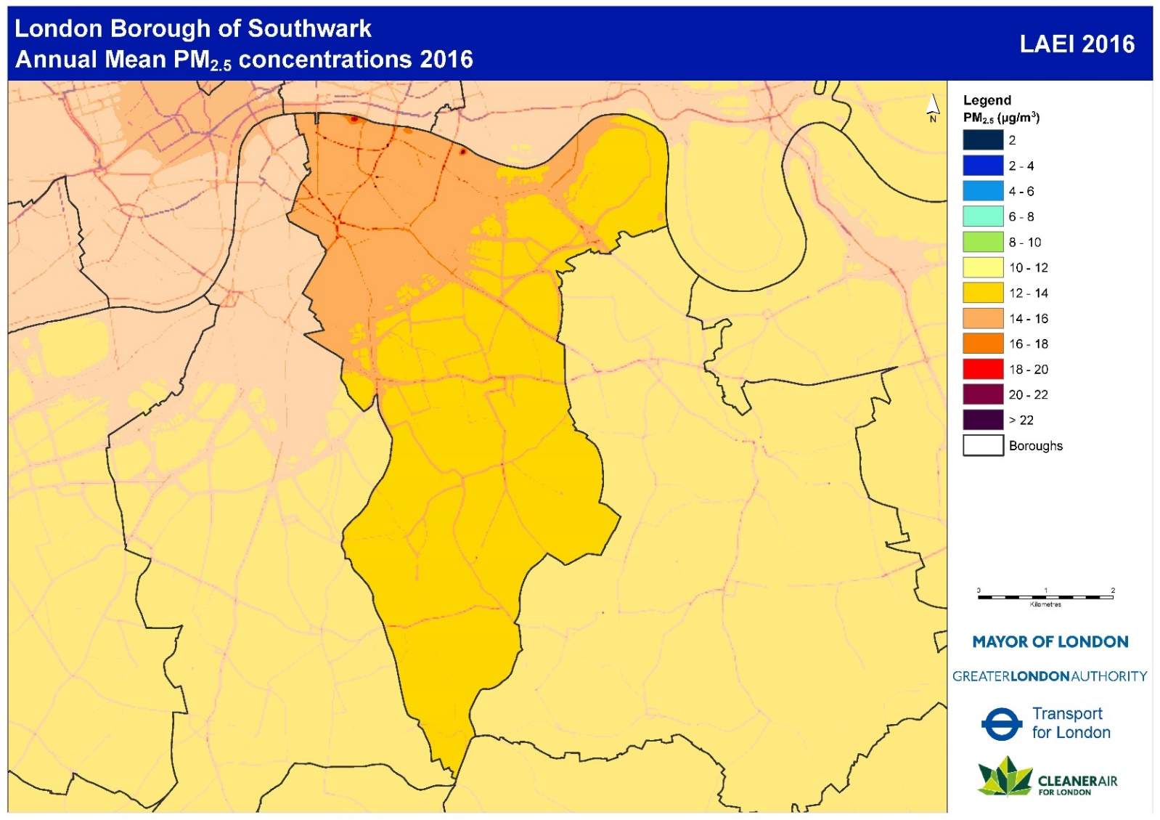

Figure 3 Modelled map of annual mean PM2.5 (from the LAEI 2016)

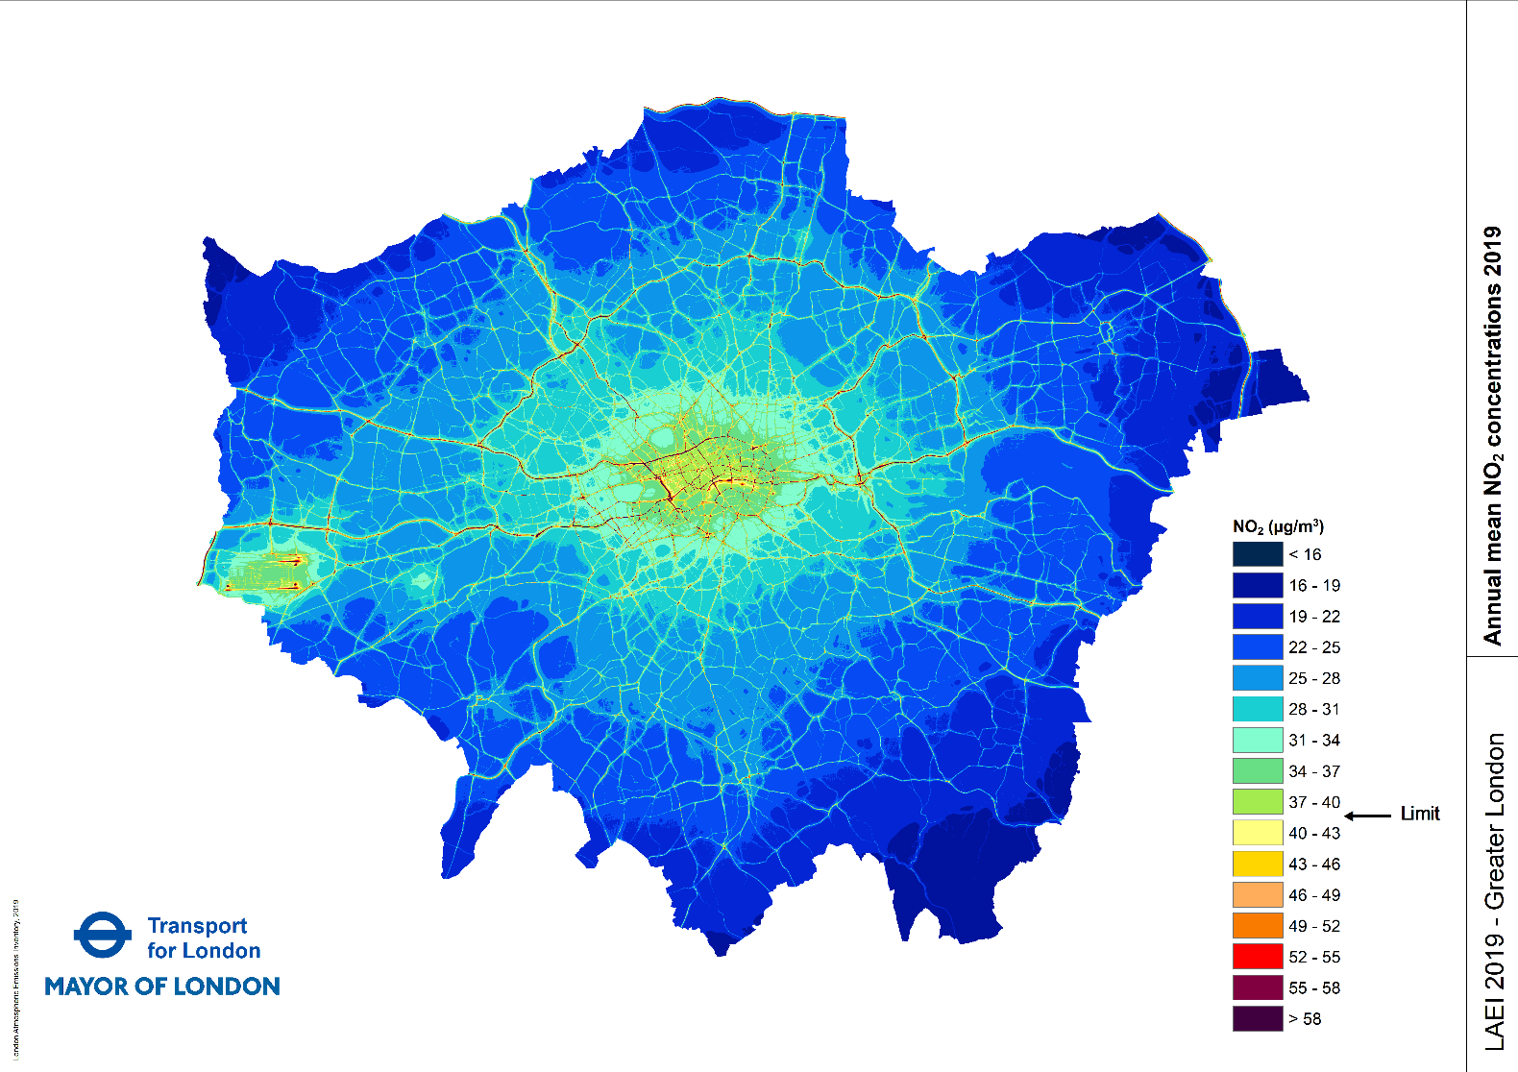

Figure 4 Modelled map of annual mean NO2 concentrations (from the LAEI 2019)

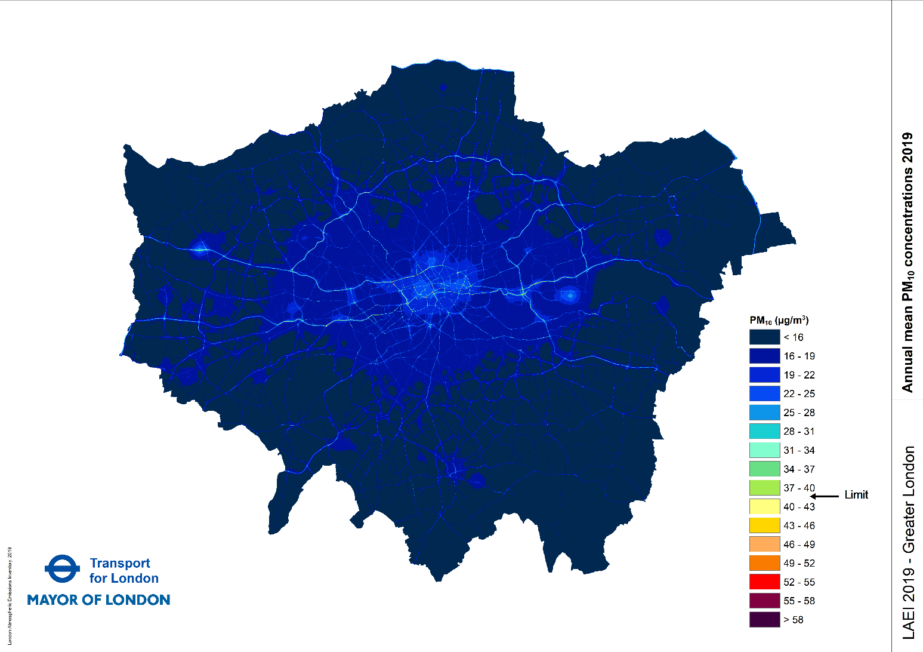

Figure 5 Modelled map of annual mean PM10 concentrations (from the LAEI 2019)

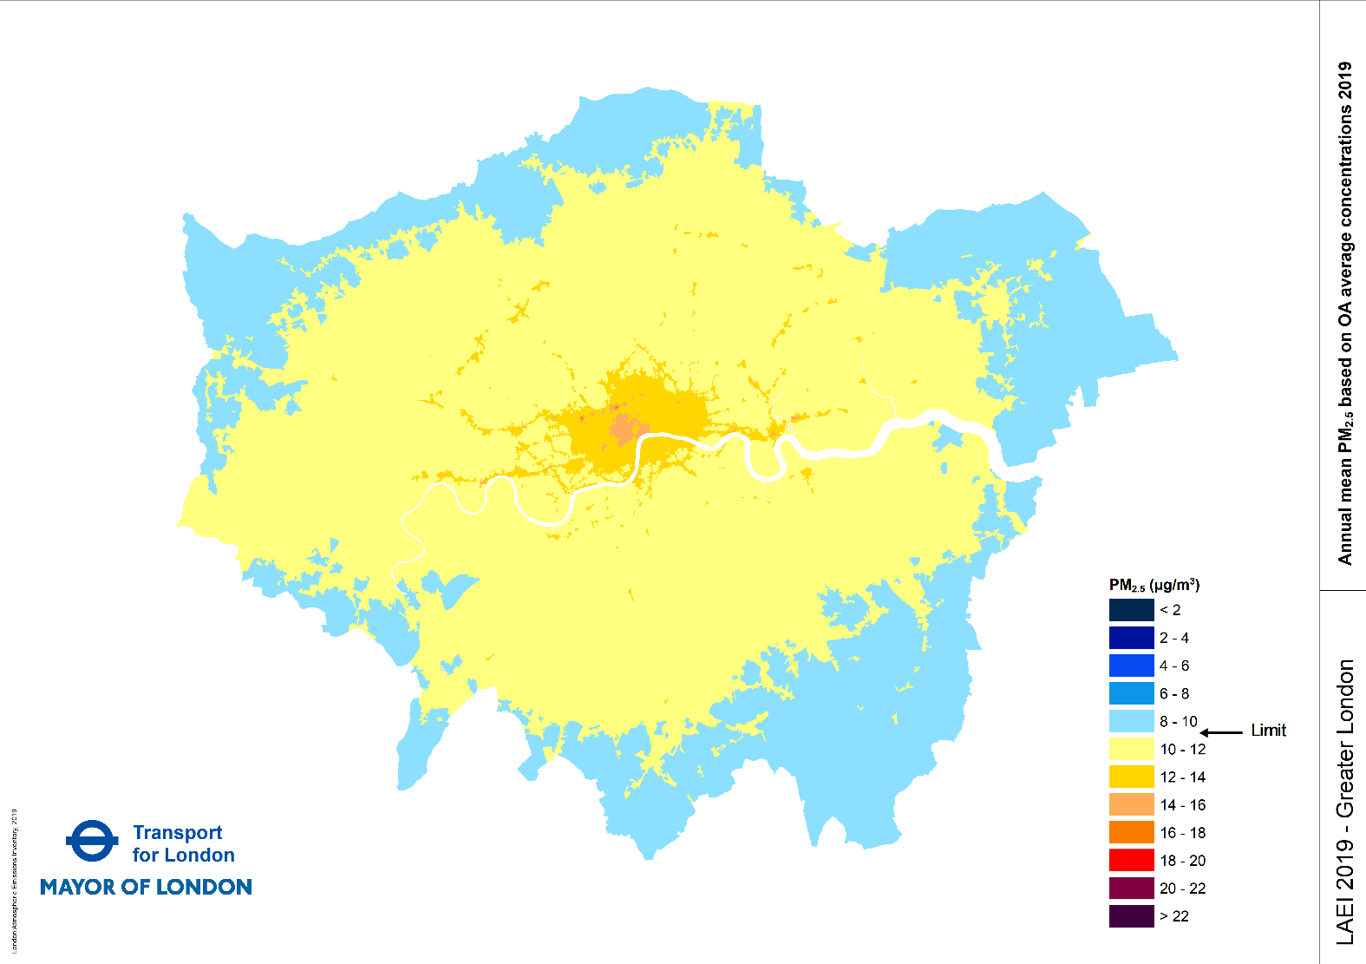

Figure 6 Modelled map of annual mean PM2.5, based on census output areasaverageconcentrations (from the LAEI 2019)

The GLA have released an updated London Atmospheric Emission Inventory in December 2021 (LAEI 2021). The Borough Maps have not been released in the current version of the LAEI 2021, due to be released in late 2022.

Figure 1 to Figure 3 above show the concentrations of Nitrogen Dioxide and Particulate Matter (PM10 & PM2.5) for Southwark. These maps are based on the data from the London Atmospheric Emission Inventory for 2016 published in 2019.Figure 1 to Figure 6 above show the concentrations of Nitrogen Dioxide and Particulate Matter (PM10 & PM2.5) for London wide. These maps are based on the data from the London Atmospheric Emission Inventory for 2019 published in 2021.

In 2016,the Greater London Authority (GLA) calculated that 62% of Southwark’s population was living in areas that exceed the Nitrogen Dioxide annual mean concentration objective of 40g.m-3, this has reduced to 2.4% for the 2019 projections. The Population Weighted Average Concentration for PM2.5 in 2016 was 14.0g.m-3, in the 2019, the Population Weighted Average Concentration for PM2.5 has been calculated to be 11.4g.m-3

In 2016 the highest concentrations in Southwark for PM10, PM2.5 and NO2 were along main roads, and in the north-west of Southwark, where the road network is most dense.

World Health Organisation (WHO) recommends maximum levels that are lower than UK legal levels. The PM2.5 WHO Air Quality Guideline 2021 air quality guideline (AQG) level has been reduced from 10g.m-3 to 5g.m-3.

The concentrations for PM10, PM2.5 and NO2 identified in the London Atmospheric Emission Inventory 2019 London wide maps exceed the revised WHO annual mean air quality guidelines throughout the Borough. Southwark Council will explore what additional measures can help meet the revised air quality guidelines or the interim targets. Some targets may not be capable of achievement.

#### **1.1 Air Quality Management Areas**

An Air Quality Management Area (AQMA) was declared In Southwark in 2003.

The AQMA was declared for:-

**Nitrogen Dioxide.** Southwark was failing to meet EU annual average limit for this pollutant at some of our monitoring stations, and modelling indicates failure also at a number of other locations, and

**Particulate Matter (PM10).** Although we are meeting EU Limits we exceed the WHO air quality guideline for this pollutant, and we have a formal responsibility to work towards reductions of PM2.5, which is a fraction of PM10.

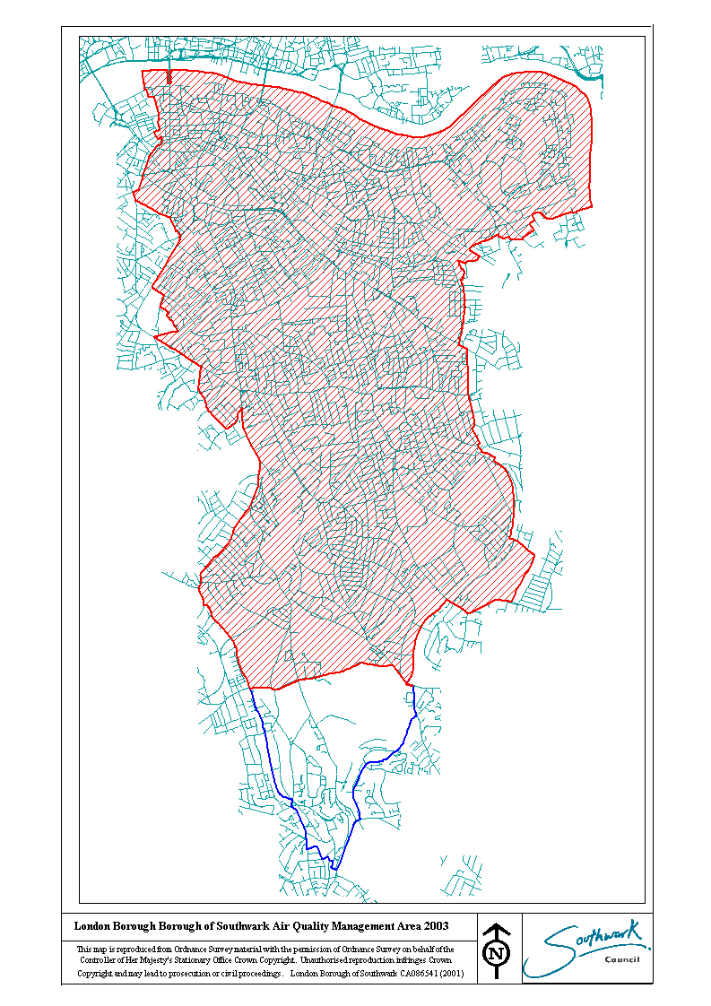

Figure 7 Map of Southwark’s AQMA Boundary

#### **1.2 Focus Areas**

Air Quality Focus Areas (AQFA) are areas where high levels of pollution are combined with high levels of human exposure. There are seven AQFA in the borough.

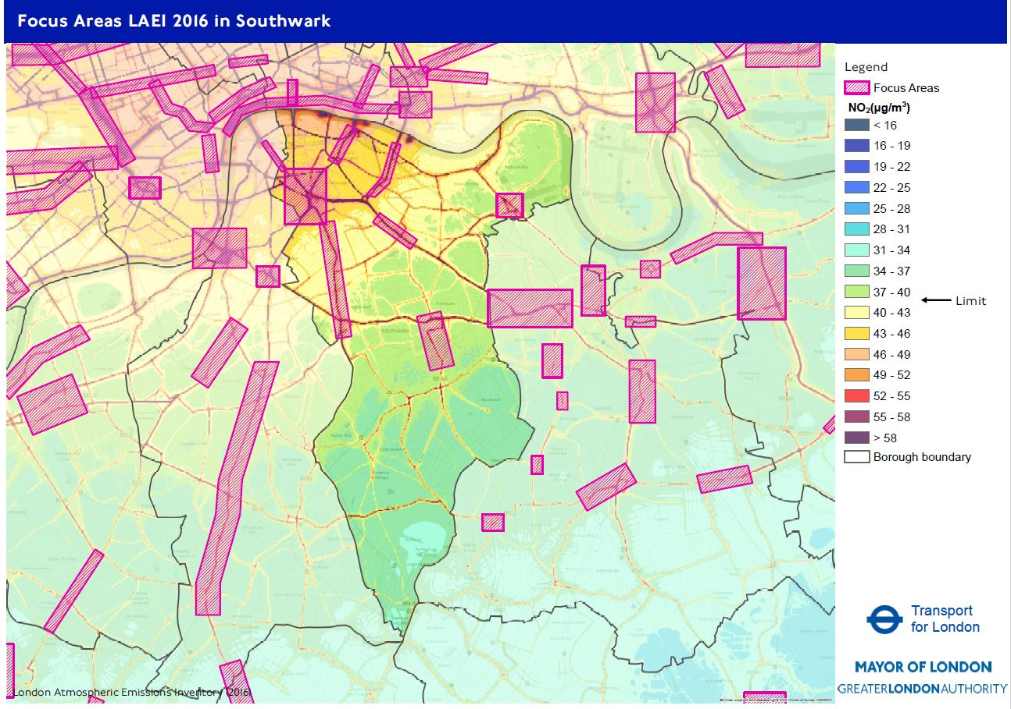

Figure 8 Air Quality Focus Areas in Southwark

These are listed in Table 1 below

|  |  |
| --- | --- |
| GLA Focus Area ID | Name of Focus Area Description |
| 151 | A2 Old Kent Road from East Street to Trafalgar Avenue |
| 152 | Elephant and Castle to St George's Circus and Kennington Lane |
| 153 | London Bridge at Borough High Street |
| 154 | Lower Road / A200 Surrey Quays / Rotherhithe Old Road / Rotherhithe New Road |
| 155 | Peckham Town Centre |
| 156 | Tower Bridge Road A100 |
| 157 | Walworth Road/Camberwell Road/Camberwell Green |

Table A GLA Air Quality Focus Areas in Southwark

##### **Old Kent Road**

The Old Kent Road is an Opportunity Area, and will be redeveloped over the next decade, including a proposal to extend the Bakerloo Line to Lewisham from the Elephant and Castle under the Old Kent Road. As part of the planning area action plan work, Southwark has commissioned CERC to produce an air quality model for the opportunity area, to ensure that air quality improvements are incorporated in the various redevelopment projects. Southwark is taking part in the [CRP Clean Air Villages 4 project](https://crossriverpartnership.org/projects/clean-air-villages-4) - Freight Solutions for a Clean Air business recovery from COVID-19 in the Old Kent Road area.

##### **Elephant & Castle**

In Elephant & Castle AQFA a London Mayor’s Air Quality Fund project included a dust suppressant trial on a construction site, to reduce the dust burden to neighbouring residential areas. A separate trial in this AQFA tested Nitrogen Dioxide reducing reactive surface coatings on new developments. The reports from these two trials can be found [here](https://www.southwark.gov.uk/environment/air-quality/what-we-re-doing/air-quality-projects)

Transport for London have also remodelled the north and south roundabouts in this area to assist the movement of vehicles and bicycles throughout the junction.

https://www.southwark.gov.uk/environment/air-quality/what-we-re-doing/air-quality-projects

##### **London Bridge / Borough High Street**

A Business Low Emission Neighbourhood initiated by the GLA was set up in 2018 in this AQFA, as a partnership between Better Bankside Business Improvement District and Team London Bridge Business Improvement District. Some of the project benefits delivered by the BIDS can be found by following the links below:-

[Tooley Street Triangle](https://www.teamlondonbridge.co.uk/triangle)

[Orchard-Lisle Living Wall](https://www.teamlondonbridge.co.uk/livingwall)

[Better Air Letters](https://betterbankside.co.uk/bankside/urban-forest/low-emissions-neighbourhood-better-air-letters/)

As a continuation of the Business Low Emission Neighbourhood, both BIDS have delivered the [Bikes for Business project](https://www.teamlondonbridge.co.uk/b4b-project) centred on the Low Line, which spans several Business Improvement Districts, and Walworth Road.

##### **Lower Road**

Past studies in the Canada Water / Lower Road area have considered removing the 1970’s Lower Road / Rotherhithe New Road gyratory system. The latest project will introduce a bus gate adjacent to Surrey Quays Station on Lower Road and the Lower Road and Rotherhithe New Road to change the one-way system to two-way traffic. Southwark will continue to monitor air quality in the area.

##### **Peckham**

As part of the London Streetscape / COVID-19 project, to help social distancing and improve the environment for walking and cycling, Rye Lane was closed to all vehicles between Peckham Rye and Hanover Place, from July 2020. From the 4th October 2021, an experimental traffic order allows buses, taxis and cyclists to use Rye Lane, and allows timed deliveries between 07:00 hours and 10: 00 hours. Southwark will continue air quality monitoring on Rye Lane.

##### **Tower Bridge**

Southwark carried out a Mayor’s Air Quality Fund project at Tower Bridge. The project aimed to reduce the number of idling vehicles during Tower Bridge lifts, by requesting drivers to switch off their engines as they will be stationery for a period of time. The details of the project can be found [here](https://www.southwark.gov.uk/environment/air-quality/what-we-re-doing/air-quality-projects).

The Tower Bridge Primary School has installed an ivy wall on the boundary wall adjacent to Tower Bridge Road. The funding for the wall was part of Southwark’s Clean, Greener and Safer Grant scheme.

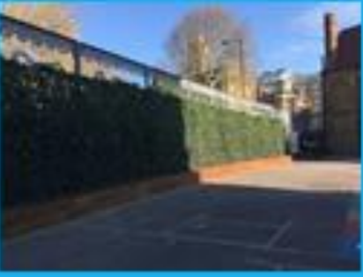

Figure 9 Tower Bridge Primary School green wall on Tower Bridge Road boundary

##### **Walworth Road and Camberwell Green**

Southwark successfully applied for Low Emission Neighbourhood Air quality Fund Grant for the Walworth LEN, which is scheduled to complete in 2022. The Walworth LEN publicity is shown in Figure 10 below

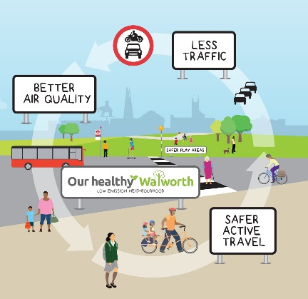

Figure 10 Walworth Low Emission Neighbourhood publicity material

Further details about Walworth Low Emission Neighbourhood can be seen at <https://ourhealthywalworthlen.commonplace.is/>

#### **1.4 Sources of Pollution in Southwark**

Pollution in Southwark comes from a variety of sources. This includes pollution from sources outside of the borough, and, in the case of particulate matter, a significant proportion of this comes from outside of London and even the UK.

The main sources of NO2 in the borough are road transport, particularly diesel vehicles, and domestic and commercial heating. The main sources of particulate matter areconstruction projects and road transport for PM10, and road transport, and commercial kitchens and construction for PM2.5 emissions.

Figure 11 NOx Emissions by source and vehicle type (from the LAEI 2016)

|  |  |  |  |  |  |  |
| --- | --- | --- | --- | --- | --- | --- |
|  | **Southwark 2013 NOx Emissions (tonnes per annual)** | **Southwark 2013 NOx Emissions (%)** | **Southwark 2016 NOx Emissions (tonnes per annual)** | **Southwark 2016 NOx Emissions (%)** | **Southwark 2019 NOx Emissions (tonnes per annual)** | **Southwark 2019 NOx Emissions (%)** |
| **Domestic** | **89.89** | **7.04%** | **71.59** | **6.39%** | **63.90** | **7.52%** |
| **Biomass** | **0.00** | **0.00%** | **0.00** | **0.00%** | **0.00** | **0.00%** |
| **Heat and Power Generation** | **89.60** | **7.01%** | **71.30** | **6.37%** | **63.61** | **7.49%** |
| **Machinery** | **0.29** | **0.02%** | **0.29** | **0.03%** | **0.30** | **0.03%** |
| **Industrial and Commercial** | **361.06** | **28.26%** | **343.00** | **30.63%** | **355.06** | **41.80%** |
| **Heat and Power Generation** | **288.85** | **22.61%** | **279.70** | **24.97%** | **293.53** | **34.56%** |
| **Commercial Cooking** | **0.00** | **0.00%** | **0.00** | **0.00%** | **0.00** | **0.00%** |
| **Construction** | **63.45** | **4.97%** | **52.66** | **4.70%** | **50.98** | **6.00%** |
| **Gas Leakage** | **0.00** | **0.00%** | **0.00** | **0.00%** | **0.00** | **0.00%** |
| **Industrial Processes** | **8.73** | **0.68%** | **10.61** | **0.95%** | **10.51** | **1.24%** |
| **Waste** | **0.03** | **0.00%** | **0.03** | **0.00%** | **0.03** | **0.00%** |
| **Miscellaneous** | **1.63** | **0.13%** | **1.42** | **0.13%** | **1.19** | **0.14%** |
| **Accidental Fires** | **1.01** | **0.08%** | **0.83** | **0.07%** | **0.67** | **0.08%** |
| **Agriculture** | **0.62** | **0.05%** | **0.59** | **0.05%** | **0.52** | **0.06%** |
| **Forestry** | **0.00** | **0.00%** | **0.00** | **0.00%** | **0.00** | **0.00%** |
| **Resuspension** |  |  |  |  |  |  |
| **Resuspension** | **0.00** | **0.00%** | **0.00** | **0.00%** | **0.00** | **0.00%** |
| **Transport** | **824.97** | **64.57%** | **703.92** | **62.85%** | **429.23** | **50.53%** |
| **Aviation** | **6.25** | **0.49%** | **6.24** | **0.56%** | **4.92** | **0.58%** |
| **Rail** | **4.55** | **0.36%** | **4.47** | **0.40%** | **4.57** | **0.54%** |
| **River** | **57.59** | **4.51%** | **75.17** | **6.71%** | **75.54** | **8.89%** |
| **Road Transport** | **756.58** | **59.22%** | **618.05** | **55.19%** | **344.19** | **40.52%** |
| **Grand Total** | **1277.56** | **100.00%** | **1119.93** | **100.00%** | **849.38** | **100.00%** |

Table B NOx Aggregated Emissions in Southwark for 2013-2019 (LAEI 2019)

The main sources of NOX in Southwark are emissions from transport with diesel vehicles being the predominant source, with heat and power generation the largest non-vehicular source.

Figure 12 PM10 Emissions by source and vehicle type (from the LAEI 2016)

Construction work associated with the redevelopment of Southwark is the largest source of Particulate Matter (PM10) emissions. Particulate Matter (PM10) from road transport is the next largest source of emissions, with private cars being the largest source. The London Mayor’s Low Emission Zone and the Ultra – Low Emission Zone, will see future emissions reductions from road transport due to renewal of vehicles in the transport fleet.

|  |  |  |  |  |  |  |
| --- | --- | --- | --- | --- | --- | --- |
|  | **Southwark 2013 PM10 Emissions (tonnes per annual)** | **Southwark 2013 PM10 Emissions (%)** | **Southwark 2016 PM10 Emissions (tonnes per annual)** | **Southwark 2016 PM10 Emissions (%)** | **Southwark 2019 PM10 Emissions (tonnes per annual)** | **Southwark 2019 PM10 Emissions (%)** |
| **Domestic** | **19.93** | **10.58%** | **14.46** | **6.99%** | **14.71** | **8.97%** |
| **Biomass** | **13.60** | **7.22%** | **8.53** | **4.12%** | **8.53** | **5.20%** |
| **Heat and Power Generation** | **6.32** | **3.36%** | **5.92** | **2.86%** | **6.18** | **3.77%** |
| **Machinery** | **0.01** | **0.00%** | **0.01** | **0.00%** | **0.01** | **0.00%** |
| **Industrial and Commercial** | **72.25** | **38.34%** | **101.45** | **49.04%** | **72.89** | **44.45%** |
| **Heat and Power Generation** | **5.37** | **2.85%** | **5.07** | **2.45%** | **5.33** | **3.25%** |
| **Commercial Cooking** | **18.63** | **9.88%** | **18.63** | **9.00%** | **19.52** | **11.90%** |
| **Construction** | **45.96** | **24.39%** | **75.25** | **36.38%** | **45.47** | **27.73%** |
| **Gas Leakage** | **0.00** | **0.00%** | **0.00** | **0.00%** | **0.00** | **0.00%** |
| **Industrial Processes** | **1.88** | **1.00%** | **2.10** | **1.01%** | **2.17** | **1.33%** |
| **Waste** | **0.41** | **0.22%** | **0.41** | **0.20%** | **0.41** | **0.25%** |
| **Miscellaneous** | **3.91** | **2.08%** | **3.87** | **1.87%** | **3.00** | **1.83%** |
| **Accidental Fires** | **3.58** | **1.90%** | **3.34** | **1.62%** | **2.46** | **1.50%** |
| **Agriculture** | **0.33** | **0.17%** | **0.53** | **0.26%** | **0.54** | **0.33%** |
| **Forestry** | **0.00** | **0.00%** | **0.00** | **0.00%** | **0.00** | **0.00%** |
| **Resuspension** | **29.18** | **14.10%** | **28.93** | **13.98%** | **25.94** | **15.82%** |
| **Resuspension** | **29.18** | **14.10%** | **28.93** | **13.98%** | **25.94** | **15.82%** |
| **Transport** | **63.16** | **33.52%** | **58.16** | **28.12%** | **47.43** | **28.92%** |
| **Aviation** | **0.03** | **0.02%** | **0.03** | **0.02%** | **0.02** | **0.01%** |
| **Rail** | **0.11** | **0.06%** | **0.12** | **0.06%** | **0.12** | **0.07%** |
| **River** | **2.29** | **1.21%** | **2.16** | **1.04%** | **2.16** | **1.32%** |
| **Road Transport** | **60.73** | **32.23%** | **55.85** | **27.00%** | **45.12** | **27.52%** |
| **Grand Total** | **188.44** | **100.00%** | **206.87** | **100.00%** | **163.97** | **100.00%** |

Table C PM10 Aggregated Emissions in Southwark for 2013 – 2019 (LAEI 2019)

Figure 13 PM2.5 Emissions by source and vehicle type (from the LAEI 2016)

Table D PM2.5 Aggregated Emissions in Southwark for 2013 – 2019 (LAEI 2019) below show that the predominant sources of PM2.5 in Southwark is from Road Transport, 30% of the total emissions, with emissions from commercial cooking producing 26% of the total emissions, and Heating and generation producing 25% of the total emissions and construction producing 7.5% of the total emissions. There are controls over emissions from road transport and from construction sites. Emissions from commercial cooking and heating are controlled only through the planning process, by requiring adequate dispersion of flue gases and suitable filtration.

|  |  |  |  |  |  |  |
| --- | --- | --- | --- | --- | --- | --- |
|  | **Southwark 2013 PM2.5 Emissions (tonnes per annual)** | **Southwark 2013 PM2.5 Emissions (%)** | **Southwark 2016 PM2.5 Emissions (tonnes per annual)** | **Southwark 2016 PM2.5 Emissions (%)** | **Southwark 2019 PM2.5 Emissions (tonnes per annual)** | **Southwark 2019 PM2.5 Emissions (%)** |
| **Domestic** | **19.91** | **21.32%** | **14.44** | **16.84%** | **14.69** | **19.42%** |
| **Biomass** | **13.60** | **14.56%** | **8.53** | **9.95%** | **8.53** | **11.27%** |
| **Heat and Power Generation** | **6.30** | **6.75%** | **5.91** | **6.89%** | **6.16** | **8.14%** |
| **Machinery** | **0.01** | **0.01%** | **0.01** | **0.01%** | **0.01** | **0.01%** |
| **Industrial and Commercial** | **31.97** | **34.24%** | **34.46** | **40.19%** | **32.68** | **43.20%** |
| **Heat and Power Generation** | **5.05** | **5.41%** | **4.73** | **5.51%** | **4.97** | **6.57%** |
| **Commercial Cooking** | **18.63** | **19.95%** | **18.63** | **21.73%** | **19.52** | **25.80%** |
| **Construction** | **6.05** | **6.48%** | **8.64** | **10.07%** | **5.64** | **7.46%** |
| **Gas Leakage** | **0.00** | **0.00%** | **0.00** | **0.00%** | **0.00** | **0.00%** |
| **Industrial Processes** | **1.88** | **2.01%** | **2.10** | **2.45%** | **2.17** | **2.87%** |
| **Waste** | **0.37** | **0.40%** | **0.37** | **0.44%** | **0.38** | **0.50%** |
| **Miscellaneous** | **3.43** | **3.68%** | **3.22** | **3.76%** | **2.40** | **3.17%** |
| **Accidental Fires** | **3.33** | **3.56%** | **3.10** | **3.62%** | **2.28** | **3.02%** |
| **Agriculture** | **0.10** | **0.11%** | **0.12** | **0.14%** | **0.11** | **0.15%** |
| **Forestry** | **0.00** | **0.00%** | **0.00** | **0.00%** | **0.00** | **0.00%** |
| **Resuspension** | **1.07** | **1.14%** | **1.06** | **1.23%** | **0.95** | **1.25%** |
| **Resuspension** | **1.07** | **1.14%** | **1.06** | **1.23%** | **0.95** | **1.25%** |
| **Transport** | **37.00** | **39.62%** | **32.55** | **37.97%** | **24.93** | **32.96%** |
| **Aviation** | **0.03** | **0.03%** | **0.03** | **0.04%** | **0.02** | **0.03%** |
| **Rail** | **0.08** | **0.09%** | **0.09** | **0.10%** | **0.09** | **0.12%** |
| **River** | **2.18** | **2.33%** | **2.05** | **2.39%** | **2.05** | **2.71%** |
| **Road Transport** | **34.71** | **37.17%** | **30.38** | **35.44%** | **22.77** | **30.09%** |
| **Grand Total** | **93.38** | **100.00%** | **85.73** | **100.00%** | **75.66** | **100.00%** |

Table D PM2.5 Aggregated Emissions in Southwark for 2013 – 2019 (LAEI 2019)

#### 1.4 Monitoring of Air Quality in Southwark

Southwark monitors air quality with automatic continuous air quality monitors, Nitrogen dioxide diffusion tubes, and low cost sensors.

The automatic continuous monitors are listed in Table E Southwark automatic continuous monitoring stations

below.

|  |  |  |
| --- | --- | --- |
| Site Reference | Location of the site | Monitoring |
| SWK 5 | Old Kent Road | Nitrogen Dioxide and Particulate Matter (PM10 & PM2.5) |
| SWK 9 | Old Kent Road | Particulate Matter (PM10 & PM2.5) |
| SWK 6 | Elephant & Castle | Nitrogen Dioxide, Particulate Matter (PM10 & PM2.5) and Ozone |
| SWK 8 | Tower Bridge Road | Nitrogen Dioxide and Particulate Matter (PM10 & PM2.5) |
| SWK A | Lower Road | Nitrogen Dioxide and Particulate Matter (PM10 & PM2.5) |
| SWK B | Vicarage Grove | Nitrogen Dioxide and Particulate Matter (PM10 & PM2.5) |
| SWK C | South Circular Road | Nitrogen Dioxide and Particulate Matter (PM10 & PM2.5) |

Table E Southwark automatic continuous monitoring stations

In 2021, Southwark has 88 Nitrogen Dioxide diffusion tube monitoring locations. The location of these sites can be seen Figure 15 below.

Southwark also monitors the air quality using various low – cost sensors. These low cost sensors are not reference monitors, and they produce indicative data. They are used to produce temporal air quality data for various highway projects.

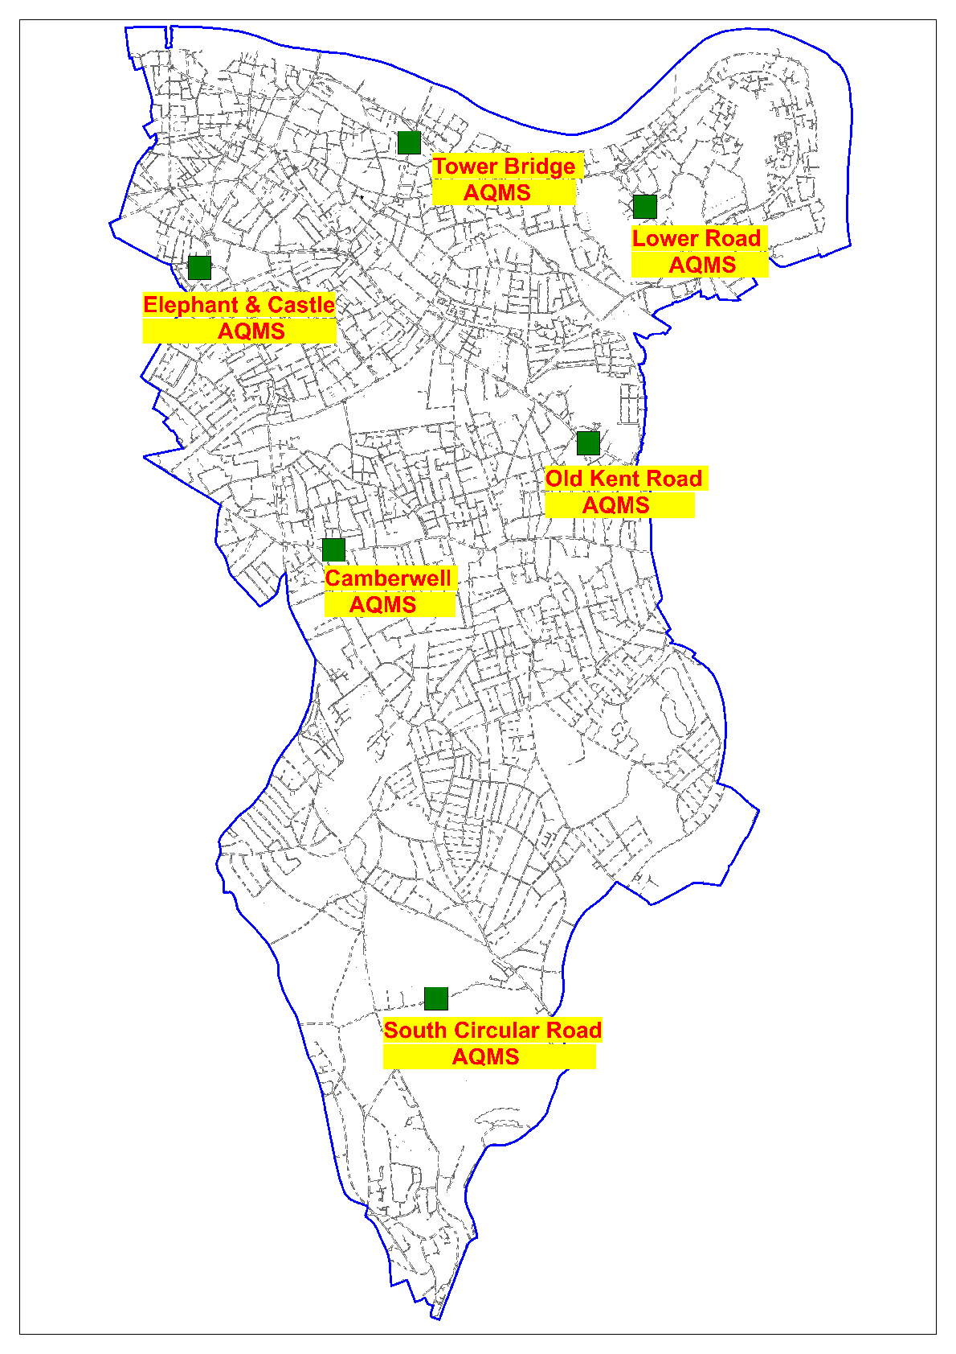

Figure 14 Map of the Southwark’s automatic continuous air quality monitoring stations

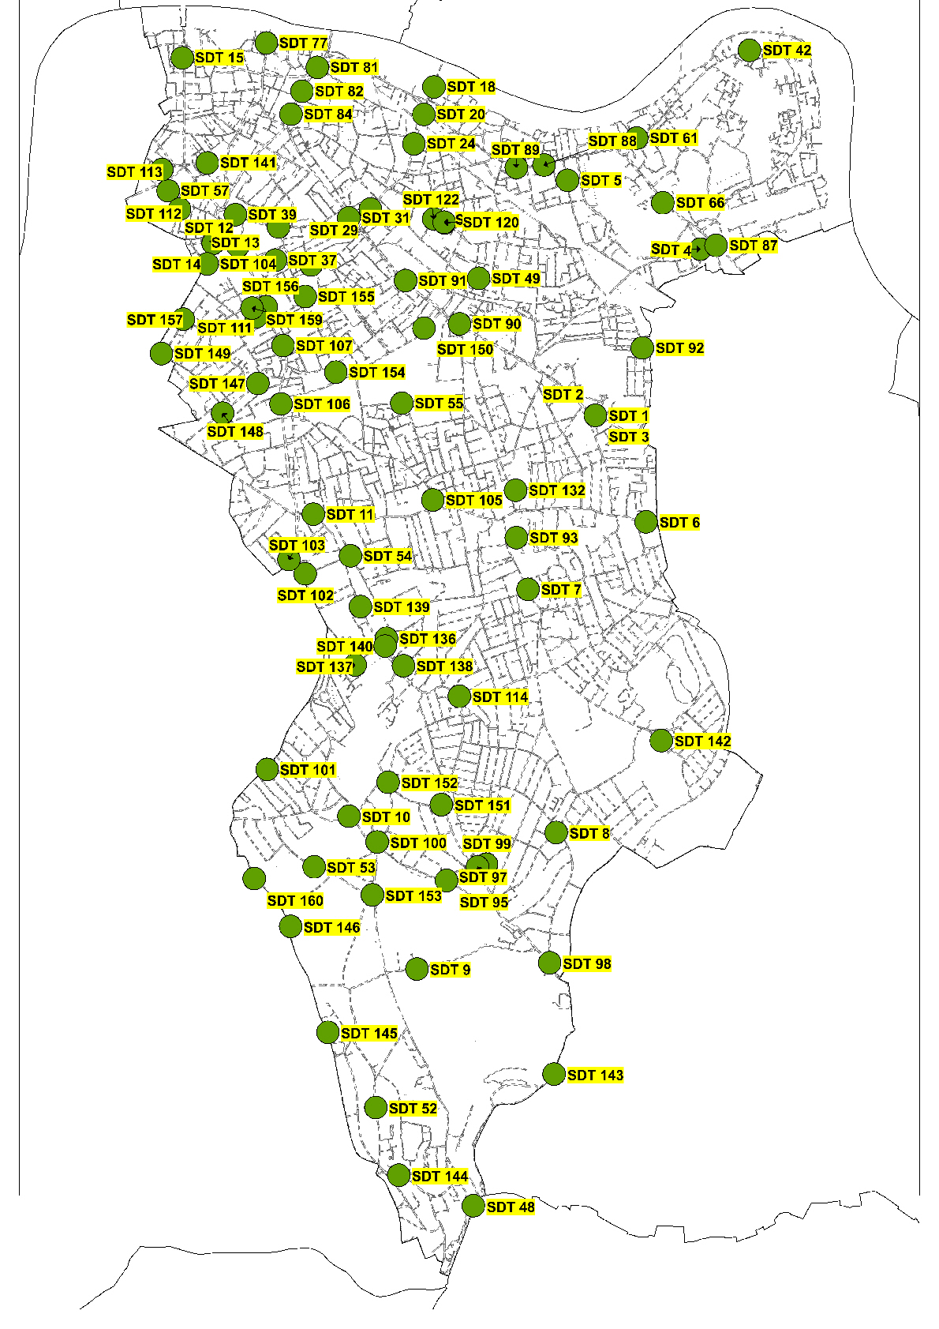

Figure 15 Southwark’s Nitrogen Dioxide diffusion tube survey 2021

Figure 16 Trend in annual mean NO2 concentrations at Southwark’s air quality monitoring stations

Figure 16 above shows historic NO2 data trends from Southwark automatic air quality monitoring stations, indicating an improvement in Southwark’s air quality since 2003. This trend is also shown for PM10 in Figure 17 below.

Figure 17 Trend in annual mean PM10 concentrations at Southwark’s air quality monitoring stations

### 2 - SOUTHWARK’S AIR QUALITY PRIORITIES

#### **2 Southwark’s Air Quality Priorities**

**Themes**

***1 Monitoring and other core statutory duties:***evaluating the air quality monitoring throughout Southwark to enhance compliance with our core statutory objectives;

***2 Emissions from development and buildings:***emissions from construction alone accounts for approximately 40% of the PM10 emissions across Southwark, and therefore work in this area is important in reducing particulate concentrations. This will focus on air quality mitigation through the planning system and correlates with the Council’s sustainability objectives;

***3 Public health and awareness raising:*** increasing awareness can drive behavioural change to lower emissions as well as reducing exposure to air pollution. For example, a shift in attitude with respect to solid fuel burning through increasing awareness of the impact this causes, can help facilitate overall behaviour change;

***4 Delivery servicing and freight:*** ensuring delivery servicing and freight vehicles are re-evaluated as these are usually heavy-duty diesel-fuelled vehicles with high primary NO2 emissions;

***5 Borough fleet:***Southwark’s fleet includes a mixture of light and specialist heavy-duty vehicles, we will continue to make improvements in our own fleet, thereby leading by example;

***6 Localised solutions:*** these seek to improve the environment of neighbourhoods through a combination of measures such as Low Traffic Neighbourhoods, traffic filtering, parking schemes biodiversity and climate change projects;

***7 Cleaner transport:***road transport is the main source of air pollution in London and Southwark. We have been and will continue to incentivise and facilitate a change to walking, cycling, public transport and ultra-low emission vehicles (such as electric) as far as possible;

***8 Schools and communities:***implementing initiatives that target the most susceptible groups in Southwark in order to ensure those most at risk are not disproportionately affected by the impacts of poor air quality and implement the recommendations from Southwark’s School Air Quality Audits;

***9 Lobbying:*** Southwark will continue to lobby and influence regional and national organisations and stakeholders on policies and issues beyond Southwark’s influence to introduce progressive measures aimed at improving air quality.

**Our 10 key priorities are:-**

1. Adopt the 2005 WHO guidelines for PM2.5 with a target of compliance deadline by 2030, and review the emerging policies from the GLA in respect of the 2021 WHO guidelines
2. Ensure enforcement of Non-Road Mobile Machinery (NRMM) air quality policies in Southwark.
3. Minimise emissions from construction through the development of Southwark’s own Air Quality Supplementary Planning Document (SPD) and code of construction for which goes above and beyond the GLA Supplementary Planning Guidance (SPG);
4. Continue to raise awareness and encourage behaviour changes through air quality campaigns
5. Assess potential impact of installing Ultra-Low Emission Vehicle (ULEV) infrastructure (electric vehicle charging points, rapid electric vehicle charging points).
6. Increase uptake of electric vehicles and ensure expansion and maintenance of electric vehicle charging infrastructure is commensurate with growth Southwark
7. Assess the air quality benefits of the actions in the Borough’s Strategies
8. Provide new cycling and walking infrastructure and assess air quality impacts of new infrastructure.
9. Deliver updated Parking and Enforcement Plan on the Southwark’s Estates to align with the On-street Parking Policies.
10. Lobby Central Government to control and reduce emissions that are out of Southwark’s control.

This action plan sets out how we will effectively deliver against the above broad themes and key priorities, thereby improving air quality issues that are within our control and through leading by example. However, it is important to recognise that these are local drivers reduced at tackling air pollution, and that air pollution by its very nature is transboundary.

### 3 - DEVELOPMENT AND IMPLEMENTATION OF SOUTHWARK’S AIR QUALITY ACTION PLAN

#### **3.1 Consultation and Stakeholder Engagement**

In developing/updating the action plan we have worked with other local authorities, agencies, businesses and the local community to improve local air quality. Schedule 11 of the Environment Act 1995 requires local authorities to consult the bodies listed in Table F. In addition we have undertaken the following stakeholder engagement:

* Southwark Council consultation hub
* Public notices in Council Offices
* Advertisement in Southwark Life (council publication)
* Advertisements in Southwark News (local independent newspaper)

Table F Consultation Undertaken

|  |  |
| --- | --- |
| **Yes/No** | **Consultee** |
|  | the Environment Agency |
|  | Transport for London and the Mayor of London (who will provide a joint response) |
|  | all neighbouring local authorities |
|  | other public authorities as appropriate |
|  | bodies representing local business interests and other organisations as appropriate See Appendix A. |

#### **3.2 Steering Group**

Southwark’s Steering Group, meets regularly under a formal structure, with senior officers from the following teams recruited into the group’s regular membership (‘primary members’):-

* Environmental Protection
* Public Health
* Transport Policy
* Planning Policy
* Sustainable Services
* Highways
* Climate Change

Other services/teams would be invited to the Air Quality Action Plan Group meetings when items relevant to their delivery responsibilities are placed on the agenda:-

* External Affairs
* Legal Services
* Public Realm
* Parks
* Ecology &Trees
* Development Control
* Children’s Services & Educational Development
* Housing Services & Housing Energy
* Fleet Management
* IT
* Comms
* Procurement

The Terms of Reference of the AQAPSG:-

1. The Air Quality Action Plan Steering Group (AQAPSG) will meet every three months.
2. The first meeting of the AQAPSG will comprise of Directors or nominated representatives from the following business areas:

* Environmental Protection
* Public Health
* Transport Policy
* Planning Policy
* Sustainable Services
* Highways
* Climate Change

### 4 – AIR QUALITY ACTION PLAN

Action Table 1 Monitoring and Core Statutory Duties Air Quality Action Plan

1 to Table 7**Error! Reference source not found.** shows the draft Southwark’s Air Quality Action Plans. It contains:

* a list of the actions that form part of the plan;
* the responsible individual and departments/organisations who will deliver this action;
* estimated cost to the council;
* expected benefit in terms of emissions and concentration reduction;
* the timescale for implementation
* the outputs, targets and Key Performance Indicators
* how progress will be monitored.

The actions have been grouped into seven categories:

* Monitoring and core statutory duties;
* Emissions from developments and buildings;
* Public health and awareness raising;
* Delivery servicing and freight;
* Borough fleet actions;
* Localised solutions; and:
* Cleaner transport

GLA nine key selected measures:

|  |  |
| --- | --- |
| The LLAQM Borough Air Quality Action Matrix says that all boroughs should be focusing on these nine key selected actions as a priority. These are the most effective to tackle exposure and/or emissions, and require concerted and consistent action across London to secure impact as soon as possible. However, this doesn’t preclude boroughs also having additional locally-appropriate priorities. | • Enforcing the Non-Road Mobile Machinery (NRMM) Low Emission Zone  • Promoting and enforcing smoke control zones  • Promoting and delivering energy efficiency retrofitting projects in workplaces and homes  • Supporting alerts services such as Airtext, and promoting the Mayor’s air pollution forecasts  • Reducing pollution in and around schools, and extending school audits to other schools in polluted areas  • Installing Ultra Low Emission Vehicle (ULEV) infrastructure   * Improving walking and cycling infrastructure * Regular Car Free days/temporary road closures in high footfall areas   • Reducing emissions from council fleets |

The 11 actions highlighted in yellow in the Action Plan tables below align with these nine elements that the GLA requires to be included in the Air Quality Action Plan.

Action Table 1 Monitoring and Core Statutory Duties Air Quality Action Plan

| **Action category** | **Action ID** | **Action name and description** | **Responsibility** | **Cost** | **Expected emissions/ concentrations benefit** | **Timescale for implementation** | **Outputs, Targets and KPIs** | **Further information** | **Technical** | **Processes** | **People** |
| --- | --- | --- | --- | --- | --- | --- | --- | --- | --- | --- | --- |
|  | Action Reference Number | Description of action to be implemented | Name of Council Department with responsibility for action implementation | Anticipated cost of action implementation  £ = 0 – 50k  ££ = 50 – 100k  £££ = >100k | High = 3  Medium = 2  Low = 1 | Proposed timescale for implementation | What the key performance Indicators for implementation will be | Links to separate document or a reference. |  |  |  |
| Southwark’s legal duty to monitor air pollution and Air Quality Action Plan | 1.1 | Maintain the Authority’s automatic air quality monitoring stations in the Borough | Environment & Leisure - Regulatory Services – Environmental Protection Team | £ | No emissions / concentrations benefits but critical in terms of understanding emissions | Ongoing for maintenance of monitors | All monitors maintained and over 90% data capture. The data from the monitoring all the sites can be found at <https://www.londonair.org.uk/london/asp/publicbulletin.asp?la_id=28&MapType=Google> | Details of our monitoring can be found here: [**https://www.southwark.gov.uk/environment/air-quality/air-quality-monitoring-data**](https://www.southwark.gov.uk/environment/air-quality/air-quality-monitoring-data) | EPT Officer.  Supported by contracted Local Site Operator, and Maintenance contract. | Review LOS and Site Maintenance reports.  Contract monitoring.  Contract re-tendering. | Internal  Contractors. |
| 1.2 | Maintain the Authority’s Nitrogen Dioxide Diffusion Tube Survey in the Borough in accordance with current guidance | Environment & Leisure - Regulatory Services – Environmental Protection Team | £ | No emissions / concentrations benefits but critical in terms of understanding emissions | Ongoing | All Diffusion tube results to be published within 5 weeks of collection on the website | Details of our monitoring can be found here: [**https://www.southwark.gov.uk/environment/air-quality/air-quality-monitoring-data**](https://www.southwark.gov.uk/environment/air-quality/air-quality-monitoring-data) | EPT Officer, supported by external accredited laboratory service. | Monthly timetabled deployment. Cold chain storage and chain of custody. | External laboratory. |
| 1.3 | Work with the GLA Breathe London Project | Environment & Leisure - Regulatory Services – Environmental Protection Team | £ | No emissions / concentrations benefits but critical in terms of understanding emissions | Ongoing | Southwark has several sites in Borough, details to be reported annually. | Details of the project can be found here **https://www.breathelondon.org/** | Automatic data reporting to Breathe London website. | Calibration, deployment, service and maintenance | GLA.  Global Action Plan.  Local community organisations. |
| 1.4 | Prepare and produce all London Local Air Quality Management Framework reports as required. | All departments | £ | No emissions / concentrations benefits | Ongoing | Submission of the Annual Status Report to the GLA  **KPI – Report submitted by the 31st May each year** | All the annual status Reports can be found at [**https://www.southwark.gov.uk/environment/air-quality/what-we-re-doing/air-quality-strategies-plans-and-letters?chapter=2**](https://www.southwark.gov.uk/environment/air-quality/what-we-re-doing/air-quality-strategies-plans-and-letters?chapter=2) |  |  | EPT.  Air Quality Steering Group. |
| Southwark’s legal duty to monitor air pollution and Air Quality Action Plan | 1.5 | Update Air Quality Action Plan every 5 years | All departments | £ | Reduction in emissions of Particulate Matter and Nitrogen Dioxide depending on the nature of the measures | Ongoing | The next full revised Air Quality Action Plan is due 2028.  **KPI - This plan will reviewed annually to ensure that it is up to date.** | The present Air Quality Action Plan can be found at[**https://www.southwark.gov.uk/environment/air-quality/what-we-re-doing/air-quality-strategies-plans-and-letters**](https://www.southwark.gov.uk/environment/air-quality/what-we-re-doing/air-quality-strategies-plans-and-letters) |  | Member briefing  Internal consultation  Public consultation  Adoption through Cabinet | Lead Member  Air Quality Steering Group  All stakeholders  Cabinet |
| 1.6 | Review The Authority’s Air Quality Management Area | Environment & Leisure - Regulatory Services – Environmental Protection Team | £ | No emissions / concentrations benefits | Ongoing | Review every year when preparing the Annual status report  **KPI – Annual review** | The current Air Quality Management Area can be found at[**https://www.southwark.gov.uk/assets/attach/3635/Southwark-air-quality-management-area-order-2003.pdf**](https://www.southwark.gov.uk/assets/attach/3635/Southwark-air-quality-management-area-order-2003.pdf) |  | Member briefing  Internal consultation  Statutory consultation  Adoption through Cabinet | Lead Member  Air Quality Steering Group  All stakeholders  Cabinet |
| 1.7 | Respond to all appropriate air quality consultations | Environment & Leisure - Regulatory Services – Environmental Protection Team | £ | Possible reduction in emissions of Particulate Matter and Nitrogen Dioxide depending on the nature of the consultation  1 - 3 | Ongoing | Consultation to be responded within consultation timetable. |  |  | Internal approvals/ member briefing | EPT Officer  Lead Member  Air Quality Steering Group |
| 1.8 | Support the introduction of a new or revised Clean Air Act that improves public protection from atmospheric pollution | Environment & Leisure - Regulatory Services – Environmental Protection Team | £ | Reduction in emissions of Particulate Matter and Nitrogen Dioxide  2 - 3 | Ongoing | To lobby Government for the introduction of the Clean Air Act and / or GLA to introduce new Clean Air provisions within a London Local Authority Act. |  |  | Internal approvals/ member briefing | GLA  London Councils  All Stakeholders |
| 1.9 | Respond to Defra Environment Act 2021 consultation in setting a PM2.5 target to improve public protection from Particulate Matter (PM2.5) atmospheric pollution | Environment & Leisure - Regulatory Services – Environmental Protection Team | £ | Reduction in emissions of Particulate Matter  2 - 3 | Ongoing | To lobby Government for the inclusion of WHO PM2.5 guidelines into the Environment Act 2021 regulations  **KPI – Report annually** | 1.9 |  | Internal approvals/ member briefing | London Councils  All Stakeholders |

| **Action category** | **Action ID** | **Action name and description** | **Responsibility** | **Cost** | **Expected emissions/ concentrations benefit** | **Timescale for implementation** | **Outputs, Targets and KPIs** | **Further information** | **Technical** | **Processes** | **People** |
| --- | --- | --- | --- | --- | --- | --- | --- | --- | --- | --- | --- |
| Southwark’s legal duty to monitor air pollution and Air Quality Action Plan | 1.10 | To explore adoption of the World Health Organization air quality guidelines | Environment & Leisure - Regulatory Services – Environmental Protection Team | £ | Reduction in emissions of Particulate Matter and Nitrogen Dioxide  1 - 3 | 2022 | L.B. Southwark to adopt the guidelines as part of Air Quality Action Plan and work with the Mayor of London towards meeting the standard by 2030  **KPI – Report annually** |  |  | As AQAP (Member briefing  Internal consultation  Statutory consultation  Adoption through Cabinet) | As AQAP  (Lead Member  Air Quality Steering Group  All stakeholders  Cabinet) |
| 1.11 | Review best practice and technical guidance on the use of Low Cost Sensors | Environment & Leisure - Regulatory Services – Environmental Protection Team | £ | No emissions / concentrations benefits but critical in terms of understanding emissions | Ongoing |  |  | EPT Officers | EPT Work plan | EPT Officers  Professional and Technical air quality forums |
| 1.12 | Embed air quality considerations in new all relevant new policies. | All Departments | £ | Reduction in emissions of Particulate Matter and Nitrogen Dioxide  1 | Ongoing | **KPI - Report annually** |  |  | Internal policy reviews | Southwark Policy Officers |

Action Table 2 Emissions from developments and buildings air quality action plan

| **Action category** | **Action ID** | **Action name and description** | **Responsibility** | **Cost** | **Expected emissions/ concentrations benefit** | **Timescale for implementation** | **Outputs,**  **Targets and**  **KPIs** | **Further information** | **Technical** | **Processes** | **People** |
| --- | --- | --- | --- | --- | --- | --- | --- | --- | --- | --- | --- |
|  | Action Reference Number | Description of action to be implemented | Name of Council Department with responsibility for action implementation | Anticipated cost of action implementation  £ = 0 – 50k  ££ = 50 – 100k  £££ = >100k | High = 3  Medium = 2  Low = 1 | Proposed timescale for implementation | What the key performance Indicators for implementation will be | Links to separate document or a reference. |  |  |  |
| Emissions from developments and buildings | 2.1 | Ensuring emissions from construction are minimised by developers fully complying with Southwark’s Technical Guidance for Demolition and Construction | Chief Executive Development Control and Environment & Leisure - Regulatory Services – Environmental Protection Team | £ | Reduction in emissions of Particulate Matter and Nitrogen Dioxide  2 - 3 | Ongoing | All major sites to submit an Air Quality Assessment in accordance the current version of the GLA’s guidance “the Control of Dust and Emissions during Construction and Demolition Supplementary Planning Guidance”  **KPI - 100% of all relevant applications** | Southwark’s Technical Guidance for Demolition and Construction can be found at <https://www.southwark.gov.uk/assets/attach/3011/Technical-Guidance-for-Demolition-Construction.pdf> | Planning policy on Air Quality  EPT guidance and GLA guidance on air quality | EPT response to consultation on Planning Applications  Planning Officer report to Planning Committee | EPT Officers  Planning Officers  Developers  Air Quality consultants  Planning Committee  Planning Inspectorate |
| 2.2 | All Major development sites to submit a demolition management (DMP) and / or Construction Management Plan (CMP) | Chief Executive Development Control and Environment & Leisure - Regulatory Services – Environmental Protection Team | £ | Reduction in emissions of Particulate Matter and Nitrogen Dioxide  2 - 3 | Ongoing | Annual reporting of number of Demolition Management Plans and Construction Management Plans that have been reviewed  **KPI – Number of reviews of Demolition Management Plans and Construction Management Plans** |  | EPT review of D/CMP | Planning consent prior approval condition.  EPT consultation on discharge of condition | EPT Officers  Planning Officers  Developers |
| 2.3 | Ensuring all medium and high risk sites have real – time PM monitoring on site and that the information from this monitoring is easily accessible to the public | Chief Executive Development Control and Environment & Leisure - Regulatory Services – Environmental Protection Team | £ - ££ | Reduction in emissions of Particulate Matter and Nitrogen Dioxide  2 - 3 | Ongoing | Annual reporting of number of sites that are reporting site monitoring  **KPI – Number of construction with site monitoring** |  | Information and data publication standards | Secured through compliance with D/CMP planning condition OR secured by s.106 agreement. | Planning Enforcement Officers  OR Development Control Officers s.106 compliance |
| 2.4 | Ensuring emissions from construction are minimised by developers by submitting a transport logistics assessment in accordance with Transport for London’s TfL) Construction Logistics guidance | Chief Executive -Development Control and Chief Executive –Transport Policy | £ | Reduction in emissions of Particulate Matter and Nitrogen Dioxide  2 - 3 | Ongoing | All major sites to submit a Transport Logistics in accordance the current version of the TfL guidance  Control of construction vehicles delivery times to reduce impact on local communities congestion and air quality  **KPI - 100% of all major sites** | The TfL’s Construction Logistics guidance can be found at [www.tfl.gov](http://www.tfl.gov) | All relevant technical guidance |  | Transport Policy Officers  TfL |
| Emissions from developments and buildings | 2.5 | Produce a construction code of practice for minor sites to be used as informative | Chief Executive Development Control and Environment & Leisure - Regulatory Services – Environmental Protection Team | £ | Reduction in emissions of Particulate Matter and Nitrogen Dioxide  2 - 3 |  | Information to be secured by either planning conditions or s106 agreements  **KPI - annual reporting of informative issued** | The GLA’s “The Control of Dust and Emissions during Construction and Demolition Supplementary planning guidance can be found at [www.gla.gov.uk](http://www.gla.gov.uk) | EPT review of submitted Air Quality Assessment | Planning consent prior approval condition.  EPT consultation on discharge of condition | EPT Officers  Planning Officers  Developers |
| 2.6 | Minimise emissions from construction by ensuring all construction site Non-Road Mobile Machinery (NRMM) comply with the London Environment Strategy Policy 4.2.3a | Environment & Leisure - Regulatory Services – Environmental Protection Team and Mayor’s Air Quality Fund South London NRMM Enforcement Project – Lead authority – currently L.B. Merton | £ | Reduction in emissions of Particulate Matter and Nitrogen Dioxide  1 - 3 | Ongoing | All relevant Planning applications to include the appropriate NRMM condition  **KPI - 100% of all relevant applications**  Southwark to provide L.B Merton an updated list of construction sites on a quarterly basis  **KPI – Four reports each year**  Southwark to subscribe to the Mayor’s Air Quality Fund South London NRMM Enforcement Project  **KPI – Annual subscription paid**  Mayor’s Air Quality Fund South London NRMM Enforcement Project to submit regular reports to Southwark  **KPI – X reports each year**  Southwark’s Environment Protection Team to investigate all non-compliant sites as reported by the NRMM Lead Authority  **KPI – All non – compliant sites investigated** |  | NRMM Regulations | Construction site inspections | NRMM Lead Authority  EPT Officers |
| Emissions from developments and buildings | 2.7 | Ensuring emissions from construction and demolition sites are minimised by developers to comply with the London Environment Strategy Policy 4.2.3 | Chief Executive Development Control and Environment & Leisure - Regulatory Services – Environmental Protection Team | £ | Reduction in emissions of Particulate Matter and Nitrogen Dioxide  2 - 3 | Ongoing | All major sites to submit an Air Quality Assessment in accordance the current version of the GLA’s The Control of dust and emissions during Construction and Demolition Supplementary Planning Guidance”  **KPI - 100% of all relevant applications**  **KPI – Annual reporting of the number of NRMM conditions / s106 interventions** | The GLA’s “The Control of Dust and Emissions during Construction and Demolition Supplementary planning guidance can be found at [www.gla.gov.uk](http://www.gla.gov.uk) | EPT review of submitted Air Quality Assessment | Planning consent prior approval condition.  EPT consultation on discharge of condition | EPT Officers  Planning Officers  Developers |
| 2.8 | Continue to control emissions from permitted processes via inspection and enforcement | Environment & Leisure - Regulatory Services – Environmental Protection Team | £ | Environment & Leisure - Regulatory Services – Environmental Protection Team  1 | Ongoing | Annual reporting of number of inspections in accordance with LAPPC risk regime and number of enforcement notices.  **KPI – Report to be submitted to Defra by the due date** |  | All relevant technical guidance | Processing applications.  Issuing permits.  Inspection and enforcement | EPT Officers |
| 2.9 | Enforce Air Quality Neutral Policy and Air Quality Positive Policy | Chief Executive Development Control and Environment & Leisure - Regulatory Services – Environmental Protection Team | £ | Reduction in emissions of Particulate Matter and Nitrogen Dioxide  1 - 3 | Ongoing | All Planning applications with boilers or other heat sources to be given a standard planning condition which requires pre-occupation information or testing reports to be submitted to Planning  **KPI - 100% of all relevant applications** |  | All relevant technical guidance | Review of combustion source information by EPT in consultation with climate change team | Planning Policy team  Climate change team  EPT Officers |
| 2.10 | Master planning and redevelopment areas aligned with the Air Quality Positive and Healthy Streets approach | Chief Executive – Planning Policy  Chief Executive - Development Control  Chief Executive – Transport Policy  Environment & Leisure - Highways | £ - £££ | Reduction in emissions of Particulate Matter and Nitrogen Dioxide  1 - 3 |  | For discussion with Planning & Transport Policy Teams, DC and Highways |  |  |  | EPT  Planning & Transport Policy Teams, Development Control  Highways |
| Emissions from developments and buildings | 2.11 | Promoting and delivering energy efficiency and energy supply retrofitting projects in workplaces and homes through EFL retrofit programmes such as RE:FIT, RE;NEW , DEEP and through Borough carbon offset funds.  (GLA mandatory action) | Housing and Modernisation  Technical services | £ - £££ | Reduction in emissions of Particulate Matter and Nitrogen Dioxide  1 - 3 | Ongoing | For discussion with Housing and Modernisation Technical Services |  | Technical survey of council owned medium sized combustion plant | Contract procurement | EPT Officers  Housing maintenance officers  Contractor  GLA |
| 2.12 | Southwark’s Smoke Control Area is fully promoted and enforced  (GLA mandatory action) | Chief Executive - Development Control – Environmental Protection Team and Environment & Leisure - Regulatory Services – Noise & Nuisance Team | £ | Reduction in emissions of Particulate Matter and Nitrogen Dioxide  1 |  | Enforce the requirements of the Clean Air Act in the Borough  **KPI - 100% of service requests investigated**  **KPI – When appropriate formal action to be taken in 100% of cases.**  Publicise on a regular basis that whole of Southwark is a Smoke Control Zone  **KPI – At least one campaign per year.**  Attend the GLA Wood Burning Working Group and contribute to the outcomes of the group. | Southwark’s Smoke Control Area can be found at <https://www.southwark.gov.uk/assets/attach/1468/smoke-control-order-2009.pdf> | All relevant technical guidance | Service requests | EPT officers  Noise and Nuisances team |
| 2.13 | Ensuring adequate, appropriate and well located green space and infrastructure is included in new and existing developments | Chief Executive Development Control | £ to £££ | No emissions reductions, but there is a small reduction in concentration near green infrastructure.  1 |  | **KPI - The number of new green infrastructure granted through the planning process in the year**  **KPI - The number of new green infrastructure implemented in the year** |  | All relevant technical guidance | Planning applications and approvals | Development control officers  Planning committee |
| Emissions from developments and buildings | 2.14 | Reducing emissions from all Combustion Plant | Chief Executive Development Control and Environment & Leisure - Regulatory Services – Environmental Protection Team | £ to £££ | Reduction in emissions of Particulate Matter and Nitrogen Dioxide  1 - 3 | Ongoing | All developments to comply with the London Plan heating hierarchy and that air quality and carbon emissions are fully assessed in planning applications  **KPI - 100% of all relevant applications**  **KPI – Annual reporting of the number of conditions / s106 interventions**  **KPI – Number of ultra-low NOX boilers / heat pumps installed in the year** |  | EPT review of relevant planning application documents, in consultation with Climate Change team | Planning applications and approvals | Development control  EPT Officers  Climate Change team  Applicants  Air Quality consultants |
| 2.15 | Reducing emissions from Combustion Plant in heating networks | Emissions from developments and buildings | £ to £££ | Reduction in emissions of Particulate Matter and Nitrogen Dioxide  1 - 3 | Ongoing | Officers to regularly update the borough – level energy masterplan and identify opportunities for new heat networks as well as extending or inter-connecting existing networks to support cleaner, lower carbon heat supply.  **KPI – Annual reporting of the number of conditions / s106 interventions**  Identifying combustion sources where cost effective carbon reduction with substantial air quality benefits  **KPI – Annual reporting of energy use in Council owned buildings.** |  | Development Control review of Energy Masterplan, in consultation with Climate Change team | Internal review | Development control  Climate Change team |
| 2.16 | To reduce emissions of Particulate Matter from commercial kitchens especially PM2.5 | Environment and Leisure  Environmental Protection Team | £ | Reduction in emissions of Particulate Matter  1 - 2 | When resources are available | Devise and complete a pilot project to produce technical guidance for kitchen operators to reduce emissions of PM2.5. |  | Guidance on exhaust flue gas filtration and smoke control | Capital bids  Project design and procurement  Member briefing | EPT officers  Future project partners  Commercial catering operation |
| Emissions from developments and buildings | 2.17 | Embed air quality in designs of estates | Chief Executive – Regeneration Team and Chief Executive – Development Control  Chief Executive – Planning Policy | £ - £££ | Reduction in emissions of Particulate Matter and Nitrogen Dioxide  1 - 3 | 2022 - 2027 | **KPI - Number of Design Briefs included air quality principles produced**  **KPI - Number of Air Quality Positive Estates built in the year** |  | All relevant technical guidance | Writing design briefs  Procurement | Development Control  Planning Policy |

Action Table 3 Public health and awareness raising air quality action

| **Action category** | **Action ID** | **Action name and description** | **Responsibility** | **Cost** | **Expected emissions/ concentrations benefit** | **Timescale for implementation** | **Outputs, Targets and KPIs** | **Further information** | **Technical** | **Process** | **People** |
| --- | --- | --- | --- | --- | --- | --- | --- | --- | --- | --- | --- |
|  | Action Reference Number | Description of action to be implemented | Name of Council Department with responsibility for action implementation | Anticipated cost of action implementation  £ = 0 – 50k  ££ = 50 – 100k  £££ = >100k | High = 3  Medium = 2  Low = 1 | Proposed timescale for implementation | What the key performance Indicators for implementation will be | Links to separate document or a reference. |  |  |  |
| Public health and awareness raising | 3.1 | Public Health having shared responsibility for borough air quality issues | Environment & Leisure - Public Health Team | £ | Reduction in emissions of Particulate Matter and Nitrogen Dioxide  1 |  | Director of Public Health to chair Air Quality Steering Group  **KPI – Annual progress report**  The Public Health Team actively involved with Air Quality Projects  **KPI – Annual progress report**  Biennial review of Southwark’s Joint Strategic Needs Assessment (Air Quality) (‘Air Quality JSNA’).  **KPI – Annual progress report**  Air Quality is a Health and Wellbeing Board priority  **KPI –Annual report to the Health and Wellbeing Board** | Southwark’s Air Quality JNSA can be found at [www.southwark.gov.uk](http://www.southwark.gov.uk) |  | EPT – public health internal consultation / collaboration on air quality projects  JSNA review | Director of Public Health  Public Health Team  EPT  Health and Wellbeing Board |
| 3.2 | Work with the Public Health Team to strengthen engagement with Southwark Clinical Commissioning Group and GP surgeries | Environment & Leisure - Public Health Team  & Environmental Protection Team | £ | Reduction in emissions of Particulate Matter and Nitrogen Dioxide by undertaking the measures in this Action Plan | Ongoing | **KPI - Report annually on the progress** |  |  |  | Southwark CCG  Public Health Team  EPT |
| Public health and awareness raising | 3.3 | Engagement on air quality issues with Business through the Borough’s Business Improvement Districts. | Chief Executive - Economic Development in partnership with the Borough’s Business Improvement Districts | £ | Reduction in emissions of Particulate Matter and Nitrogen Dioxide  1 | Ongoing | For discussion with Economic Development Team  **KPI – Number of businesses actively engaged on air quality**  **KPI – Number of businesses acting to reduce emissions** |  |  |  | Economic Development Team  EPT  BIDs |
| 3.4 | Southwark supports Airtext and promotes and shares the GLA high pollution alert services  (GLA mandatory action) | Environment & Leisure - Public Health Team  Environment & Leisure - Regulatory Services – Environmental Protection Team | £ | No emissions / concentrations benefits but helps avoid or mitigate the effects of high exposure | Ongoing | Southwark annual subscription to the Airtext service operated by Cambridge Environmental Research Consultants (CERC)  To promote the Airtext service through the GP’s and other health providers  **KPI - Number of Airtext subscribers in the Borough.**  To cascade the London Mayors High and very High pollution alerts  **KPI –100% High and Very High alerts cascaded.** |  | Air Quality Monitoring Stations  London Air Quality Network  AirText alerts system  GLA alerts system | Promotion of airText  Operation of air quality alerts cascade system to Schools,  Care Homes, and  GP Surgeries | GLA  CERC  EPT  Schools  Care Homes  GP Surgeries |
| 3.5 | Improve the uptake of Air Quality information to vulnerable persons in the Borough  (GLA mandatory action) | Environment & Leisure - Regulatory Services – Environmental Protection Team & Public Health Team | ££ | None | 2023  Ongoing | Implementation of recommendations in the Air Alert Discovery project  **KPI - Annual Communication Plan and campaign of relevant air quality improvement topics** |  | All relevant technical documents | Commission or deliver in house an air quality information campaign | EPT  Communications team |
| 3.6 | To assess the feasibility of providing air quality information at health care facilities, libraries, pharmacies and other frequently used facilities  (GLA mandatory action) | Environment & Leisure - Regulatory Services – Environmental Protection Team & Public Health Team | £ - ££ | None | 2023 | **KPI - Annual progress reports** |  |  | EPT – public health internal consultation / collaboration on air quality projects | EPT  Public Health team  Relevant partners and stakeholders working in this area, e.g. Impact on Urban Health charity |
| Public health and awareness raising | 3.7 | Promote School Air Quality Audits to all schools in the Borough  (GLA mandatory action) | Environment & Leisure - Regulatory Services – Environmental Protection Team  Environment & Leisure – Sustainable Travel | £ | Reduction in emissions of Particulate Matter and Nitrogen Dioxide | Ongoing | To promote the London Mayor’s School Pollution Helpdesk and GAP’s online ‘school air quality audit’ to all schools that have not received a Southwark Schools Air Quality Audit, |  | Schools’ air quality audit template | Audit Procurement | EPT  Education  External air quality auditors |
| 3.8 | Reducing pollution in and around schools  (GLA mandatory action) | Environment & Leisure  Highways  Environment & Leisure - Regulatory Services – Environmental Protection Team | £ - £££ | Reduction in emissions of Particulate Matter and Nitrogen Dioxide | Ongoing | Implementation of recommendations from the Southwark Schools’ Air Quality Audits |  | School audit reports |  | EPT  Education  Highways |
| 3.9 | Encourage schools to join the TfL STARS accredited travel planning programmes | Environment & Leisure – Sustainable Travel Team | £ | Reduction in emissions of Particulate Matter and Nitrogen Dioxide  1 | Ongoing | Proportion of schools in Southwark with STARS Bronze, Accreditation each year  Proportion of schools in Southwark with STARS Silver Accreditation each year  Proportion of schools in Southwark with STARS Gold Accreditation each year  The total number of schools in Southwark is 94  **KPI - To increase the proportion of schools at each stage by X% per year.** |  | TfL guidance |  | EPT  Highways Sustainable travel team  Education  TfL |
| 3.10 | Assess the feasibility of creating clean air zones around schools/hospitals / care homes | Environment & Leisure - Highways | ££ | Reduction in emissions of Particulate Matter and Nitrogen Dioxide  2 | 2022 | **KPI - Annual progress report** |  |  |  |  |
| 3.11 | To create school super zones in the Borough | Environment & Leisure –  Public Health Team | £ | Reduction in emissions of Particulate Matter and Nitrogen Dioxide  1 - 2 |  | Annual progress report  **KPI – Number of School Super zones in the Borough** |  |  |  |  |
| Public health and awareness raising | 3.12 | To create school walking maps for all schools in the Borough | Environment & Leisure –  Sustainable Travel Team | £ | Reduction in emissions of Particulate Matter and Nitrogen Dioxide  1 - 2 | 2022 - 2027 | Annual progress report  **KPI – Number of School walking maps in the Borough** |  |  | Capital bid | Highways sustainable travel team |
| 3.13 | Raising awareness about indoor air quality | Environment & Leisure –  Environment Protection Team | £ | Reduction in emissions of Particulate Matter and Nitrogen Dioxide  1 | When funding is available | To produce a toolkit on domestic and commercial indoor air pollution and how to reduce personal exposure  **KPI – Indoor Air Quality produced** |  |  | Capital bid |  |
| 3.14 | Review the progress of recommendation 13 of the Chief Medical Officers report 2017   * 1. Southwark Clinical Commissioning Group (CCG) Groups should analyse local air quality monitoring data for breaches of air pollution standards, and publish these alongside the local hospital data for impacts on admissions for respiratory and cardiovascular disease and   2. Public Health England should aggregate and analyse progress annually for a national public report to NHS England | Environment & Leisure –  Public Health Team | £ | No emissions / concentrations benefits but critical in terms of understanding emissions | When resources are available | **KPI - Annual progress report** |  |  |  | Southwark CCG  Public Health team  Public Health England |

Action Table 4 Delivery servicing and freight air quality action plan

| **Action category** | **Action ID** | **Action name and description** | **Responsibility** | **Cost** | **Expected emissions/ concentrations**  **benefit** | **Timescale for**  **implementation** | **Outputs, Targets and KPIs** | **Further information** | **Technical** | **Process** | **People** |
| --- | --- | --- | --- | --- | --- | --- | --- | --- | --- | --- | --- |
|  | Action Reference Number | Description of action to be implemented | Name of Council Department with responsibility for action implementation | Anticipated cost of action implementation  £ = 0 – 50k  ££ = 50 – 100k  £££ = >100k | High = 3  Medium = 2  Low = 1 | Proposed timescale for implementation | What the key performance Indicators for implementation will be | Links to separate document or a reference. |  |  |  |
| Delivery servicing and freight | 4.1 | Use procurement policy to reduce pollution from logistics and servicing | Chief Executive - Procurement | £ | Reduction in emissions of Particulate Matter and Nitrogen Dioxide  1 - 3 | Ongoing | Where appropriate, air quality criteria are included within the specification of the contract and to be monitored during the contract  KPI - Reported on an annual basis |  | Procurement guidance |  | Procurement |
| 4.2 | Reducing emissions from delivering to local businesses and residents | Chief Executive – Transport Policy | £££ | Reduction in emissions of Particulate Matter and Nitrogen Dioxide  1 - 3 | Ongoing | Percentage increase in Ultra Low emission Vehicles to undertake deliveries in Southwark  **KPI - Number of Consolidation / last mile delivery schemes in Southwark** |  |  |  | Transport policy team  BIDs |
| 4.3 | Explore the feasibility of installing of Virtual Loading Bays throughout the Borough in the Town centres. | Environment and Leisure - Highways | ££ | Reduction in emissions of Particulate Matter and Nitrogen Dioxide  2 -3 | 2023 - 2027 | Annual progress reporting  **KPI – Number of Virtual Loading Bays in the Borough** |  |  | Trial in Walworth LEN | EPT  Parking services  Highways  External contractors |
| 4.4 | Explore with the Port of London Authority (PLA) the methods of control of shipping emissions and use of shipping to mitigate land based emissions | Environment & Leisure –  Environment Protection Team | £££ | Reduction in emissions of Particulate Matter and Nitrogen Dioxide  2 -3 | 2023 - 2027 | Annual progress reporting  **KPI – Reduction in NOx, PM10 & PM2.5 emissions** |  |  |  | EPT  PLA |

Table 5

Action Table 5 Borough fleet actions air quality action plan

| **Action category** | **Action ID** | **Action name and description** | **Responsibility** | **Cost** | **Expected emissions/ concentrations**  **benefit** | **Timescale for**  **implementation** | **Outputs, Targets and KPIs** | **Further information** | **Technical** | **Process** | **People** |
| --- | --- | --- | --- | --- | --- | --- | --- | --- | --- | --- | --- |
|  | Action Reference Number | Description of action to be implemented | Name of Council Department with responsibility for action implementation | Anticipated cost of action implementation  £ = 0 – 50k  ££ = 50 – 100k  £££ = >100k | High = 3  Medium = 2  Low = 1 | Proposed timescale for implementation | What the key performance Indicators for implementation will be | Links to separate document or a reference. |  |  |  |
| Borough fleet actions | 5.1 | Reducing emissions from Council Fleets  (GLA mandatory action) | Environment & Leisure – Fleet Services | £££ | Reduction in emissions of Particulate Matter and Nitrogen Dioxide  2 - 3 | Ongoing | Smarter Driver training for all fleet drivers  **KPI All new drivers to receive training within six months of starting in Southwark**  Monitor the mileage and Fuel use reports passed to Business Unit Managers  **KPI – Reduce the fuel usage by X% per year**  Every commercial vehicle procured to undergo full sustainability evaluation  **KPI – Reduction of Fossil fuel combustion vehicles by X% over three years**  **KPI – Proportion of vehicles within the Fleet that are either electric, hydrogen, or hybrid.**  **KPI – Monitor and report on the EVCP at Tooley Street and Queens Road monthly** |  |  |  | Fleet Services |

Action Table 6 Localised solutions air quality action plan

| **Action category** | **Action ID** | **Action name and description** | **Responsibility** | **Cost** | **Expected emissions/ concentrations**  **benefit** | **Timescale for**  **implementation** | **Outputs,**  **Targets and**  **KPIs** | **Further information** | **Technical** | **Process** | **People** |
| --- | --- | --- | --- | --- | --- | --- | --- | --- | --- | --- | --- |
|  | Action Reference Number | Description of action to be implemented | Name of Council Department with responsibility for action implementation | Anticipated cost of action implementation  £ = 0 – 50k  ££ = 50 – 100k  £££ = >100k | High = 3  Medium = 2  Low = 1 | Proposed timescale for implementation | What the key performance Indicators for implementation will be | Links to separate document or a reference. |  |  |  |
| Localised solutions | 6.1 | Green infrastructure | Chief Executive – Regeneration  Chief Executive – Development Control  Environment & Leisure – Highways | £ - £££ | Reduction in emissions of Particulate Matter and Nitrogen Dioxide  1 | Ongoing | Monitoring and reporting of the impact of the Green Infrastructure projects.  **KPI - Number of Green Infrastructure projects implemented by Southwark during the year.** |  |  |  |  |
| 6.2 | Low Emission Neighbourhood | Chief Executive – Transport Policy  Environment & Leisure Climate Change  Environment & Leisure – Highways  Environment & Leisure – Regulatory Services – Environmental Protection Team | £££ | Reduction in emissions of Particulate Matter and Nitrogen Dioxide  1 - 3 | To be completed by Dec 2022  From January 2022 | Complete the MAQF Low Emission Neighbouring in the Walworth Area  Explore the opportunities to introduce further Low Emission neighbourhoods in Southwark when funding is available. |  |  | Evaluation report | EPT  GLA  Highways |
| 6.3 | To lobby the Central and the GLA for policy changes to improve air quality in Southwark | Chief Executive – External Affairs | £ | Reduction in emissions of Particulate Matter and Nitrogen Dioxide  1 - 3 | Ongoing | **KPI - Annual Reporting on progress** |  |  |  |  |
| 6.4 | Explore the feasibility with the Environment Agency to stop issuing D7 waste exemption: burning waste in the open registration. | Environment & Leisure – Regulatory Services – Environmental Protection Team | £ | Reduction in emissions of Particulate Matter  1 -2 | From January 2022 | **KPI - Annual Reporting on progress** |  |  |  | EPT  Environment Agency |
| Localised solutions | 6.5 | Apply for Mayor’s Air Quality Funds and Defra Air Quality Grant to deliver air quality projects in Southwark | All | £ | Reduction in emissions of Particulate Matter and Nitrogen Dioxide  1 - 3 | Ongoing | **KPI - Annual Reporting on progress and project reports**. |  |  |  | EPT |
| 6.6 | To link the measures in Southwark’s Climate Strategy and this action plan | Environment & Leisure Climate Change and  Environment & Leisure – Regulatory Services – Environmental Protection Team | £ - £££ | Reduction in emissions of Particulate Matter and Nitrogen Dioxide  1 - 3 | Ongoing | A reduction of Greenhouse Gases and Particulate Matter and Nitrogen Dioxide |  |  | Review of each other’s strategies and action plans | EPT  Climate Change Team |

Action Table 7 Cleaner transport air quality action plan

| **Action category** | **Action ID** | **Action name and description** | **Responsibility** | **Cost** | **Expected emissions/ concentrations**  **benefit** | **Timescale for**  **implementation** | **Outputs,**  **Targets and**  **KPIs** | **Further information** | **Technical** | **Process** | **People** |
| --- | --- | --- | --- | --- | --- | --- | --- | --- | --- | --- | --- |
|  | Action Reference Number | Description of action to be implemented | Name of Council Department with responsibility for action implementation | Anticipated cost of action implementation  £ = 0 – 50k  ££ = 50 – 100k  £££ = >100k | High = 3  Medium = 2  Low = 1 | Proposed timescale for implementation | What the key performance Indicators for implementation will be | Links to separate document or a reference. |  |  |  |
| Cleaner transport | 7.1 | Transport and air quality policies and projects are integrated | Chief Executive – Transport Policy  Environment & Leisure – Highways  Environment & Leisure – Regulatory Services – Environmental Protection Team | £ - £££ | Reduction in emissions of Particulate Matter and Nitrogen Dioxide  1 - 3 | Ongoing | **KPI - The number of Healthy Streets projects delivered during the year.**  **KPI - The number of meetings between Transport Policy and Environment Protection Team**  **KPI - The number of walking and cycling infrastructure projects delivered during the year.** |  |  |  | EPT  Transport Policy |
| 7.2 | Discouraging unnecessary idling by taxis and other vehicles | Environment & Leisure – Parking | £ | Reduction in emissions of Particulate Matter and Nitrogen Dioxide  1 | Ongoing | Percentage of drivers complying with requests from Civil Enforcements Officers to switch the vehicle’s engine off.  **KPI - Number of PCN’s issued per year.** |  |  |  | Parking enforcement |
| 7.3 | Regular temporary car free days and pedestrianisation schemes in line with proposal 4.2.1a of the London Environment Strategy  (GLA mandatory action) | Environment & Leisure - Sustainable Travel | £ | Reduction in emissions of Particulate Matter and Nitrogen Dioxide in the local area of the event  1 |  |  |  |  |  | EPT  Sustainable travel team |
| 7.4 | Lobby the London Mayor to extend the Ultra-Low Emission Zone to the M25 | Chief Executive – Transport Policy | £ | Reduction in emissions of Particulate Matter and Nitrogen Dioxide  1 -3 | 2027 |  |  |  | Response to ULEZ consultations | Transport Policy |
| Cleaner transport | 7.5 | Using parking policy to reduce pollution emissions | Environment & Leisure – Parking | £ | Reduction in emissions of Particulate Matter and Nitrogen Dioxide  2 - 3 | Ongoing | **KPI - Percentage of vehicles using the Southwark Pay and Display bays where the non-ULEZ tariff is applied**  **KPI - Percentage of the total for on-street resident’s vehicles permit claiming a discount for hybrid and electric vehicles.**  **KPI - Percentage of the total for resident’s vehicles permits where the non –ULEZ surcharge has been applied.**  **KPI - Percentage of the total for on-street Business vehicles permit claiming a discount for hybrid and electric vehicles.**  **KPI - Percentage of the total for Business vehicles permits where the non –ULEZ surcharge has been applied** | **Pay and Display diesel vehicle surcharge** – Diesel vehicles which are non-ULEZ compliant will pay a 25% higher tariff to park in Southwark Pay and Display bays from 06 April 2021.  **Resident’s vehicles who park in on-street parking bays** – From 06 April 2021 in addition to the pre-existing discount for hybrid and electric cars there will also be a diesel non-ULEZ surcharge of £120 per annum applied. Residents with older non-ULEZ diesels will see their permit price go up from £125 in 2020 to £250 after 06 April 2021.  **Business who park in on-street parking bays –** From 06 April 2021 in addition to the pre-existing discount for hybrid and electric cars there will also be a diesel non-ULEZ surcharge of £120 per annum applied.  Businesses with older non-ULEZ diesels will see their permit price go up from £590 in 2020 to £720 after 06 April 2021 |  | Review of fees and charges | Parking Services |
| 7.6 | Using parking policy to reduce pollution emissions  (GLA mandatory action) | Housing and Modernisation | £ | Reduction in emissions of Particulate Matter and Nitrogen Dioxide  2 - 3 |  | To ensure that the estate parking permits are have a similar policy as on-street parking permits policy |  |  | Review of fees and charges | Housing & Parking services |
| 7.8 | Provision of infrastructure to support walking and cycling  (GLA mandatory action) | Chief Executive – Transport Policy  Environment & Leisure - Highways | £ to £££ | Reduction in emissions of Particulate Matter and Nitrogen Dioxide  2 - 3 | Ongoing | **KPI - The length of dedicated cycle paths installed in Southwark**  **KPI - Number of secure cycle parking spots across Southwark**  **KPI - Number of cycle-hire docking points in the Borough**  **KPI Percentage increase in cycling**  **KPI - Percentage increase in walking**  **KPI - The number of Low Transport neighbourhoods in the Borough**  **KPI - Number of improved signage installed** |  |  |  |  |
| Cleaner transport | 7.7 | Installation of Ultra – low emission Vehicle infrastructure charging points  (GLA mandatory action) | Chief Executive – Transport Policy  Environment & Leisure – Trading Services | £££ | Reduction in emissions of Particulate Matter and Nitrogen Dioxide  2 - 3 | Ongoing | **KPI - Number of electric vehicles registered in Southwark**  **KPI - The number of Slow / Fast Electric Vehicle charging points in Southwark**  **KPI - The number of Rapid Electric Vehicle charging points in Southwark** |  |  |  |  |
| 7.9 | Consolidate patient transport to reduce the number of vehicles on the road subject to health and safety of patient | Environment & Leisure – Regulatory Services – Environmental Protection Team | £ | Reduction in emissions of Particulate Matter and Nitrogen Dioxide  2 - 3 | 2023 | **KP I- Annual report of progress** |  |  |  |  |
| 7.10 | Explore the possibility of improving dropping off area at the main entrance to Guy’s hospital | Environment & Leisure – Regulatory Services – Environmental Protection Team | ££ | Reduction in emissions of Particulate Matter and Nitrogen Dioxide  2 - 3 | 2023 | **KPI - Annual report of progress** |  |  |  |  |
| 7.11 | Investigate the feasibility of introducing a Work Place Parking Levy | Chief Executive – Transport Policy | £ | Reduction in emissions of Particulate Matter and Nitrogen Dioxide  2 - 3 | 2023 | **KPI - Annual report of progress** |  |  |  |  |

### APPENDIX A – RESPONSE TO CONSULTATION

Table G Summary of Responses to Consultation and Stakeholder Engagement on the AQAP

| **Consultee** | **Category** | **Response** |
| --- | --- | --- |
| Secretary of State - Defra | Statutory Consultee |  |
| London Mayor | Statutory Consultee |  |
| Environment Agency | Statutory Consultee |  |
| L.B. Lambeth | Local Authority |  |
| L.B. Lewisham | Local Authority |  |
| L.B. Bromley | Local Authority |  |
| L.B. Croydon | Local Authority |  |
| City of London | Local Authority |  |
| L. B. of Tower Hamlets | Local Authority |  |
| Port of London Authority | Public Trust |  |
| South East London Clinical Commission Group | Health Provider |  |
| NHS London | Health Provider |  |
| Maudsley Hospital | Health Provider |  |
| Guy’s and St Thomas Hospital | Health Provider |  |
| Better Bankside | Business Improvement District |  |
| Team London Bridge | Business Improvement District |  |
| The Blue | Business Improvement District |  |
| We Are Waterloo | Business Improvement District |  |
| South Bank | Business Improvement District |  |
| Southwark Chamber of Commerce | Business |  |
| London College of Art | Higher Education |  |
| Southbank University | Higher Education |  |
| Impact on Urban Health | Air Quality Partner |  |
| Camberwell Society | Local Society |  |
| Walworth Society | Local Society |  |
| Dulwich Society | Local Society |  |
| Southwark Friends of the Earth | Local Environmental Group |  |
| Southwark Greens | Local Environmental Group |  |
| Public Consultation on the website | General |  |

### APPENDIX B - REASONS FOR NOT PURSUING ACTION PLAN MEASURES

Table H Action Plan Measures Not Pursued and the Reasons for that Decision – *to be discussed with the GLA prior to finalisation*

|  |  |  |
| --- | --- | --- |
| **Action category** | **Action description** | **Reason action is not being pursued (including Stakeholder views)** |
| e.g. Localised solutions | *e.g. Low Emission Neighbourhoods* | *e.g. we have been unable to obtain funding, although we have developed an outline plan for LEN in xx location and will try to obtain funding for delivery of this over the coming year* |

1. Environmental equity, air quality, socioeconomic status and respiratory health, 2010.
2. Air quality and social deprivation in the UK: an environmental inequalities analysis, 2006.
3. Defra. Air Pollution: Action in a Changing Climate, March 2010
4. LLAQM Policy and Technical Guidance. https://www.london.gov.uk/what-we-do/environment/pollution-andair-quality/working-boroughs