Tell us what you want Southwark to be like in the future
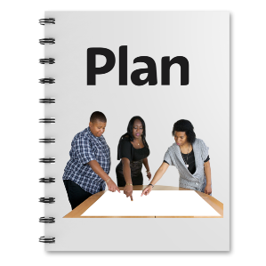
Southwark Council wants your help to make a plan for the future.

We want to know what matters most to you.

We want to know what you want Southwark to be like in the future.

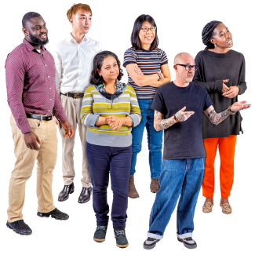

We want to hear from lots of people that live or spend time in Southwark.
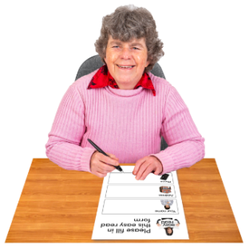

You can have your say by filling in this form.

There are other ways to have your say. Find out more at www.southwark.gov.uk/southwark2030
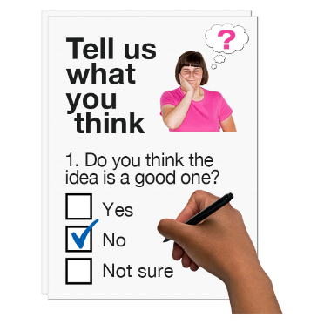
This form

Please answer the questions in this form.

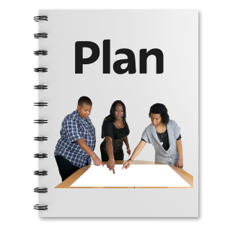

Your answers will help us make a plan for the future.
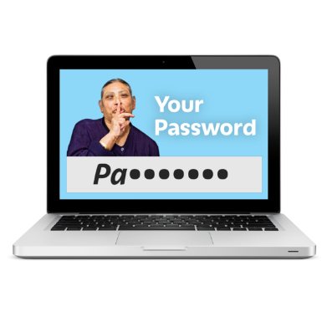

We will keep your answers safe.
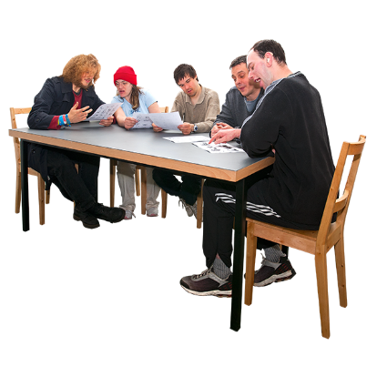

We will only share your answers with people that need to see them.

If you have questions about what we will do with your answers you can
- email dpo@southwark.gov.uk
- call 0207 525 5000.

What matters most to you?

Please tick 3 things

Having a say about things that matter to me
Being treated fairly
Learning new things
Staying healthy
Children and families
My area
Staying safe
Going to places like museums and festivals
Green spaces like parks
Buses, trains and other transport
Climate change
Having a job
Money
My home
Other __________________

Tell us more
1

Please write the first thing you ticked in this box.

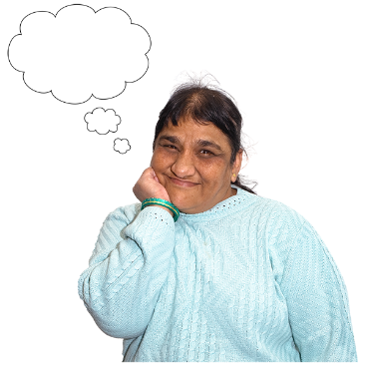
What do you want to happen in the future about this?

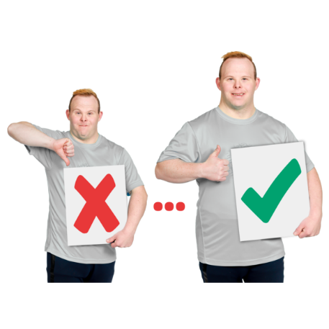

What needs to change to make this better?

Tell us more
2

Please write the second thing you ticked in this box.

What do you want to happen in the future about this?

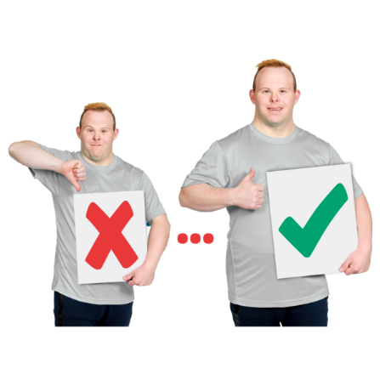

What needs to change to make this better?

Tell us more
3

Please write the third thing you ticked in this box.

What do you want to happen in the future about this?

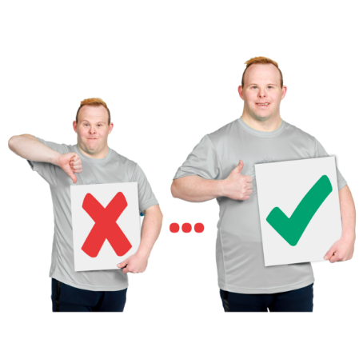

What needs to change to make this better?

About you

Why are you filling in this form?
I live in Southwark
I work in Southwark
I run a business in Southwark
I study in Southwark
My child studies in Southwark
I visit Southwark
I work for Southwark Council
Other _______________________
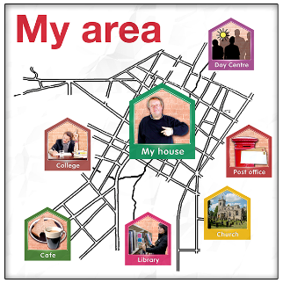
If you live in Southwark which area do you live in?
Bermondsey Camberwell
Dulwich Nunhead
Peckham Rotherhithe
Walworth Borough and Bankside
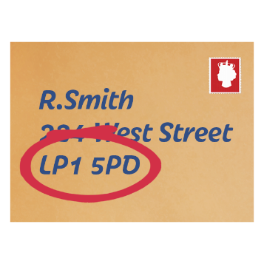
Elephant and Castle

What is your postcode?

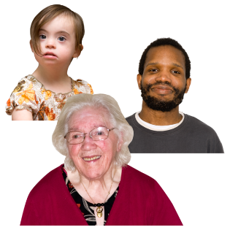
You do not have to answer the next questions but it would help us if you did.

How old are you?

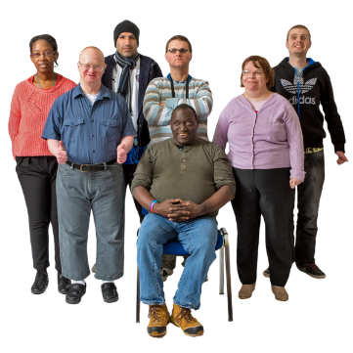
Are you?
White British White other
Black Mixed
Asian Chinese
Gypsy/ Irish Traveller
Don’t want to say
Other_________________
Do you have a disability?
Yes No

If yes what type of disability do you have?
Hearing or seeing Physical
Mental health Learning disability
Don’t want to say
Other________________

Are you?
Male Female
Other Don’t want to say
Please tell us more below if you want to.

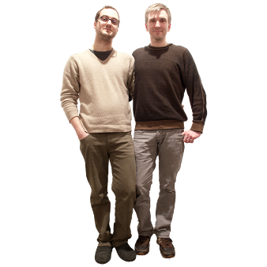
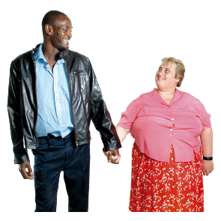
Are you?
Straight Gay man
Bisexual Gay woman or lesbian
Don’t want to say
Other______________
Do you have a religion or belief?
Christian Sikh
Hindu Muslim
Jewish Buddhist
No religion Don’t want to say
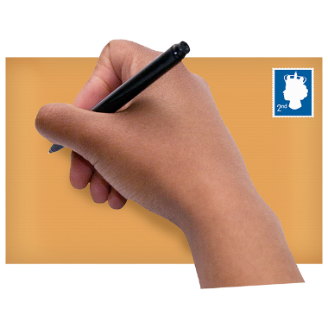
Other_______________
Thank you for filling in this form. Please send it to Community Engagement Team, Southwark Council, 5th Floor, 160 Tooley Street, London SE1P 5LX

